Exploring toehold-mediated strand displacement as a strategy to program DNAzyme-catalyzed peroxidation localized to DNA condensates
EMILY TERKAZARYAN¹, ELIANA SAFAR², CYNTHIA KHOSRAVIAN³, GRACIOUS MHLANGA³, MEGAN RIVERA³, ELISA FRANCO⁴, JILLIAN L. BLATTI^{3*}
¹Department of Molecular, Cell and Developmental Biology, University of California, Los Angeles, 610 Charles E Young Dr S, Los Angeles, CA 90095, USA
² Department of Psychological & Brain Sciences, University of California, Santa Barbara, CA 93106, USA
³NSF Future Manufacturing Undergraduate Research Program; Department of Chemistry, Pasadena City College, 1570 E. Colorado Blvd, Pasadena, CA 91106
⁴Department of Mechanical and Aerospace Engineering; Bioengineering, University of California, Los Angeles, 7400 Boelter Hall, Los Angeles, CA 90095

*jblatti@pasadena.edu

Supporting Information

© 2025 under the terms of the J ATE Open Access Publishing Agreement

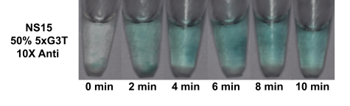

Fig. S1. DNAzyme-catalyzed peroxidation reaction in a single layer system on the microscale with 10X concentration of displacer strand and hemin added pre-annealing. After forming DNA nanostars on the microscale by adding hemin and heating to 95°C for ten minutes, then cooling slowly to room temperature at a rate of 1°C/min in a thermocycler, peroxidation was carried out by adding ABTS and H₂O₂ substrates directly into the solution. Like the same experiment conducted in Figure 4 with 2X and 5X concentrations of displacer and hemin added pre-annealing, the reaction mixture turned just as blue as the positive control, suggesting that toehold-mediated strand displacement was not successful here.

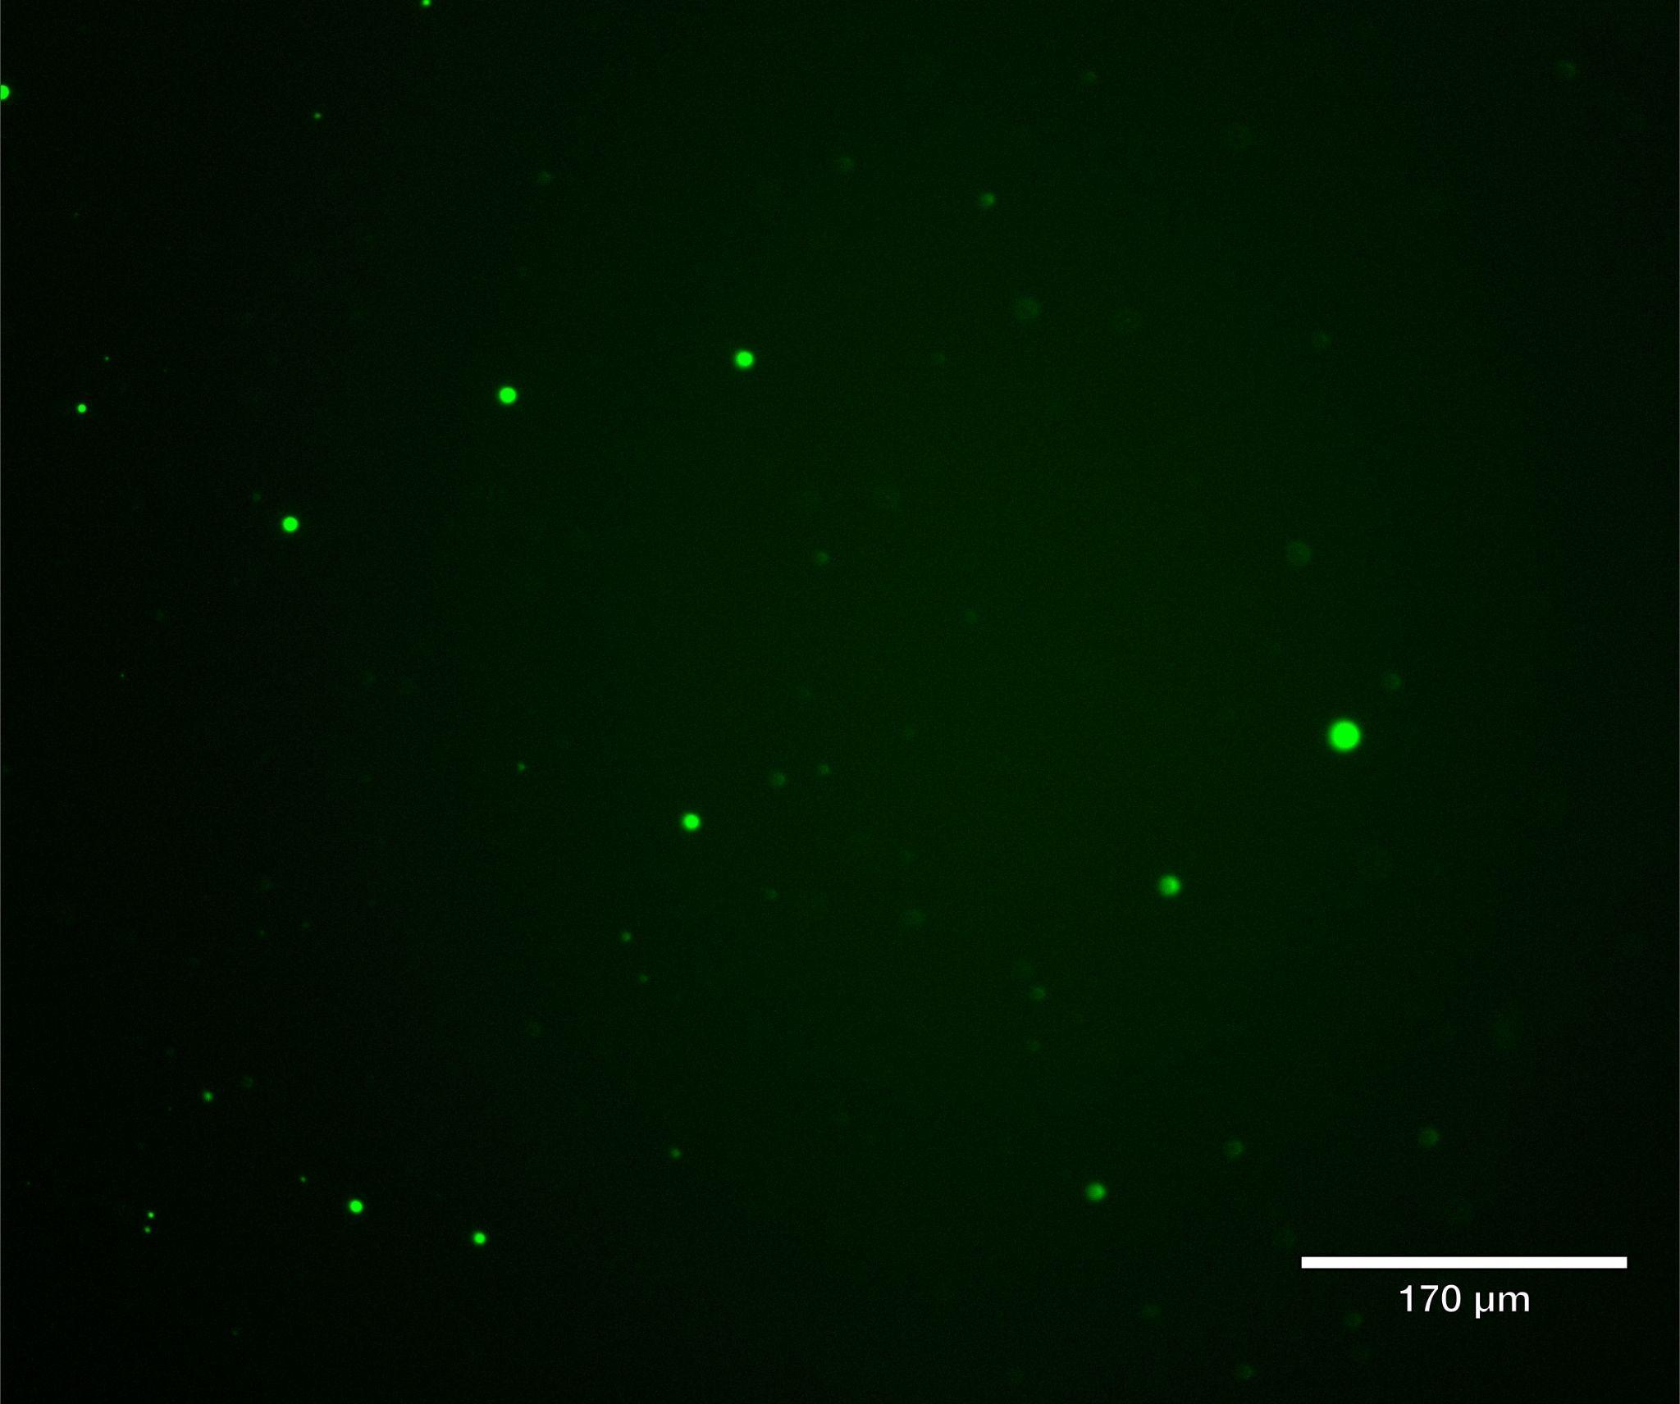

Fig. S2. Micrograph of microscale NS15/50% 5xG3T-T1 DNA condensates with 10X displacer strand concentration (Fig. S1) visualized via addition of dilute SYBR dye under the FITC channel.

Table S1. Summary of DNA strands used in this study
Name | Concentration | Sequence
polyT18 | 120 µM | 5’- TTT TTT TTT TTT TTT TTT -3’
5xG3T | 189 µM | 5’- GGG TGG GTG GGT GGG TGG GT -3’
5xG3T-T1-displacer | 162 µM | 5’- ACC CAC CCA CCC ACC CAC CCA CCT CTC A -3’
nstar15_strand1 | 973 µM | 5’- CTA GTC TAC AGT GCC AAC TGG GCA GAA TTC CCA GCT AGC -3’
nstar15_strand2 | 934 µM | 5’- GGG AAT TCT GCC CAG AAC GTC ACC AGA AGC ACA GCT AGC -3’
nstar15_strand3 | 901 µM | 5’- GTG CTT CTG GTG ACG AAG ACG GAA TCT CCG TCA GCT AGC -3’
nstar15_strand4 | 925 µM | 5’- GAC GGA GAT TCC GTC AAG GCA CTG TAG ACT AGA GCT AGC -3’
nstar15_strand4-5xG3T | 181 µM | 5’- GGG TGG GTG GGT GGG TGG GTG ACG GAG ATT CCG TCA AGG CAC TGT AGA CTA GAG CTA GC -3’
nstar15_strand4-5xG3T-T1 | 171 µM | 5’- TGA GAG GTG GGT GGG TGG GTG GGT GGG TGA CGG AGA TTC CGT CAA GGC ACT GTA GAC TAG AGC TAG C -3’

Table S2. Forming NS15/50% 5xG3T Reaction Mixture (Positive Control)
Reagent | Initial Concentration (µM) | Final Concentration (µM) | Volume Added (µL)
nstar15_strand1 | 97.3 | 19.00 | 9.76
nstar15_strand2 | 93.4 | 20.00 | 10.71
nstar15_strand3 | 90.1 | 20.00 | 11.10
nstar15_strand4 | 92.5 | 10.00 | 5.41
nstar15_strand4-5xG3T | 181 | 10.00 | 2.76
KCl (mM) | 2000 | 350.00 | 8.75
trisHCl (mM) | 200 | 20.00 | 5.00
Total Volume | –– | –– | 50.00
*Initial concentrations for strands 1-4 (excluding strands with 5xG3T or T1) are based on concentrations after a tenfold dilution from the concentrations listed in Table S1.
**Enough milliQ water was added to the positive control tubes to balance the volume of displacer strands that would be added to the experimental tubes.

Table S3. Forming NS15/50% 5xG3T-T1 2X Displacer Reaction Mixture
Reagent | Initial Concentration (µM) | Final Concentration (µM) | Volume Added (µL)
nstar15_strand1 | 97.3 | 19.00 | 9.76
nstar15_strand2 | 93.4 | 20.00 | 10.71
nstar15_strand3 | 90.1 | 20.00 | 11.10
nstar15_strand4 | 92.5 | 10.00 | 5.41
nstar15_strand4-5xG3T-T1 | 171 | 10.00 | 2.93
5xG3T-T1-displacer* | 162 | 20.00 | 6.18
KCl (mM) | 2000 | 350.00 | 8.75
trisHCl (mM) | 200 | 20.00 | 5.00
Hemin in 1X Buffer** | –– | –– | 6.00
Total Volume | –– | –– | 50.00
*The displacer strand was added before annealing or after annealing (2 minutes after peroxidation had begun) depending on the experimental tube.
**The hemin buffer solution was added before annealing or after annealing depending on the experimental tube.

Table S4. Forming NS15/50% 5xG3T-T1 5X Displacer Reaction Mixture
Reagent | Initial Concentration (µM) | Final Concentration (µM) | Volume Added (µL)
nstar15_strand1 | 97.3 | 19.00 | 9.76
nstar15_strand2 | 93.4 | 20.00 | 10.71
nstar15_strand3 | 90.1 | 20.00 | 11.10
nstar15_strand4 | 92.5 | 10.00 | 5.41
nstar15_strand4-5xG3T-T1 | 171 | 10.00 | 2.93
5xG3T-T1-displacer* | 162 | 50.00 | 15.46
KCl (mM) | 2000 | 350.00 | 8.75
trisHCl (mM) | 200 | 20.00 | 5.00
Hemin in 1X Buffer** | –– | –– | 6.00
Total Volume | –– | –– | 50.00
*The displacer strand was added before annealing or after annealing (2 minutes after peroxidation had begun) depending on the experimental tube.
**The hemin buffer solution was added before annealing or after annealing depending on the experimental tube.

Table S5. Forming NS15/50% 5xG3T-T1 10X Displacer Reaction Mixture
Reagent | Initial Concentration (µM) | Final Concentration (µM) | Volume Added (µL)
nstar15_strand1 | 97.3 | 19.00 | 9.76
nstar15_strand2 | 93.4 | 20.00 | 10.71
nstar15_strand3 | 90.1 | 20.00 | 11.10
nstar15_strand4 | 92.5 | 10.00 | 5.41
nstar15_strand4-5xG3T-T1 | 171 | 10.00 | 2.93
5xG3T-T1-displacer* | 162 | 100.00 | 30.91
KCl (mM) | 2000 | 350.00 | 8.75
trisHCl (mM) | 200 | 20.00 | 5.00
Hemin in 1X Buffer** | –– | –– | 6.00
Total Volume | –– | –– | 50.00
*The displacer strand was added before annealing with the 10X displacer experimental tube.
**The hemin buffer solution was added before annealing with the 10X displacer experimental tube.

