Molecular Visualization in Nanotechnology Education, Research, and Outreach: Simulating Catalytic DNA Nanostars Using oxDNA

EMILY TERKAZARYAN¹, REINA SALMAN², FABIANA PAREDES³, VANESSA GONZALEZ⁴, ELIANA SAFAR⁵, WING LAM YU¹, MEGAN RIVERA⁶, GRACIOUS MHLANGA⁶, CYNTHIA KHOSRAVIAN⁶, DAISY PITHAWALLA², TANEEKA ANAND⁷, BRITNEY CASTANEDA CAMACHO⁷, HEATHER ROMERO MERCIECA⁸, MAHDI DIZANI⁸, ELISA FRANCO⁸, JILLIAN L. BLATTI^{6*}
¹Department of Molecular, Cell and Developmental Biology, University of California, Los Angeles, 610 Charles E Young Dr S, Los Angeles, CA 90095, USA
²Department of Chemical and NanoEngineering, University of California, San Diego, 9500 Gilman Drive, La Jolla, CA 92093, USA
³Department of Biological Sciences, California State University, Long Beach, 1250 Bellflower Blvd., Long Beach, CA 90840-9502, USA
⁴Department of Chemistry and Biochemistry, California State University, Los Angeles, 5151 State University Drive, Los Angeles, CA 90032, USA
⁵Department of Psychological & Brain Sciences, University of California, Santa Barbara, CA 93106, USA
⁶NSF Future Manufacturing Undergraduate Research Program; Division of Natural Sciences and Department of Chemistry, Pasadena City College, 1570 E. Colorado Blvd., Pasadena, CA 91106, USA
⁷Department of Ecology and Evolutionary Biology, University of California, Los Angeles, 612 Charles E Young Dr S, Los Angeles, CA 90095, USA
⁸Department of Mechanical and Aerospace Engineering; Bioengineering, University of California, Los Angeles, 7400 Boelter Hall, Los Angeles, CA 90095, USA
* jblatti@pasadena.edu, pccnanostars@gmail.com

Supporting Information

Table used to form fluorescent NS 15 FAM DNA condensates……..……….....……p. 2
Guide for simulating a DNA nanostar without a G-tetraplex…………..…….….pp. 2-10
Guide for extending a G-tetraplex from Arm 4 of the DNA Nanostar….....….pp. 10-15
Tables used to conduct the DNAzyme-catalyzed peroxidation reaction..…..pp. 16-17
Supporting Figures for a DNAzyme-catalyzed peroxidation reaction.….….….….p. 18
Student Worksheet…………………………………………………….……….……..pp. 19-22
Student Survey Responses…….…………………………………….…….….….…..…..p. 23
References………………………………………………….……………….………....…….p. 24

Table S1. Forming Fluorescent DNA Nanostar-Condensates: NS15 FAM
Reagent | Diluted/Initial Concentration (µM) | Final Concentration (µM) | Volume Added (µL)
nstar15_strand1 | 97.3 | 19.00 | 9.76
nstar15_strand2 | 93.4 | 20.00 | 10.71
nstar15_strand3 | 90.1 | 20.00 | 11.10
nstar15_strand4 | 92.5 | 20.00 | 10.81
nstar15_strand1-5FAM | 50.0 | 1.00 | 1.00
KCl (mM) | 2000 | 350.00 | 8.75
trisHCl (mM) | 200 | 20.00 | 5.00
Total Volume | –– | –– | 50.00
*Initial concentrations for strands 1-4 are based on concentrations after a tenfold dilution. Stock concentrations of fluorescent dyes attached to arm 1 were also diluted to 50 µM before use.

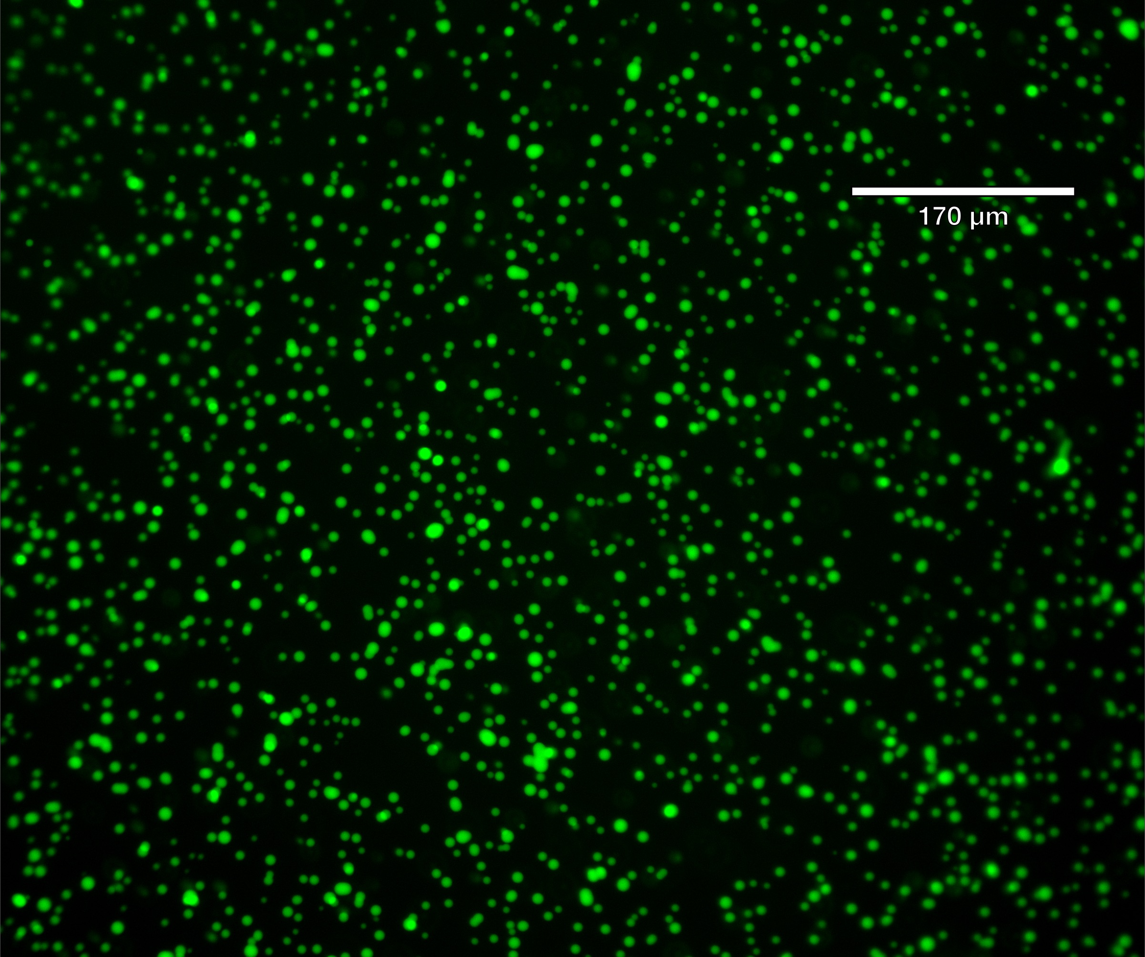
Above: visualization of NS15 nanostar condensates using an Echo Revolve microscope. DNA condensates were formed from a solution of DNA strands, KCl, Tris-HCl according to amounts in Table S1, which were thoroughly mixed, heated to 95 °C for ten minutes, then slowly cooled to room temperature at a rate of 1 °C/min.

As students are forming the DNA nanostar condensates in vitro and visualizing them on the microscope, they are simulating the dynamics of the nanostructure in silico using oxDNA.

Simulating a DNA nanostar without a G-tetraplex

The creation of the DNA nanostar in oxView starts with manually adding the DNA strand sequences into the program. As illustrated in Figure S1, a 4-armed nanostar comprises various components: the green font marks the core sequence of arm one, while purple, pink, and blue fonts denote the remaining arms. Spacers, highlighted in blue as AA-doubles, and sticky ends, shown in gray, are integral to the nanostar’s structure. The underlined DNA bases are those directly entered into oxView.

Color coding the strands, as shown in Figure S1, facilitates efficient creation and tracking. Initially, the focus is on strand 4’s DNA bases, marked in green font, which compose the core sequence of arm one. This systematic approach aids in the clear assembly and visualization of the DNA nanostar's structure in the simulation environment.

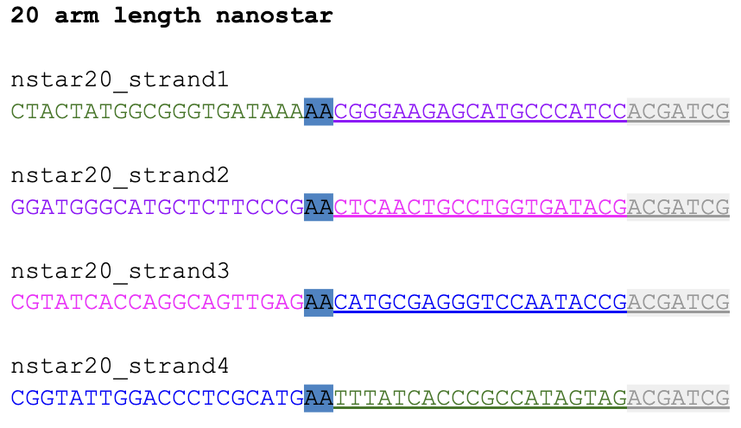
Fig. S1. DNA base sequences for a 20 base-pair, 4-armed nanostar. Each strand is color-coded to delineate different structural components: core sequences in green, spacers in blue, and sticky ends in gray. The complementary sequences are visually connected by the color coding, highlighting the self-assembly design of the nanostar structure, which is critical for intermolecular interactions.

To initiate the creation of a DNA double-strand on oxView, the process begins by entering the “Edit” mode. Next, “Duplex mode” is activated to allow for the automatic generation of a complementary strand. After inputting the desired DNA sequence into the “Seq” box, the “Create” button is pressed. This action culminates in the visualization of a DNA double-strand (Fig. S2), aligned centrally with the interface’s 3D axis vectors.

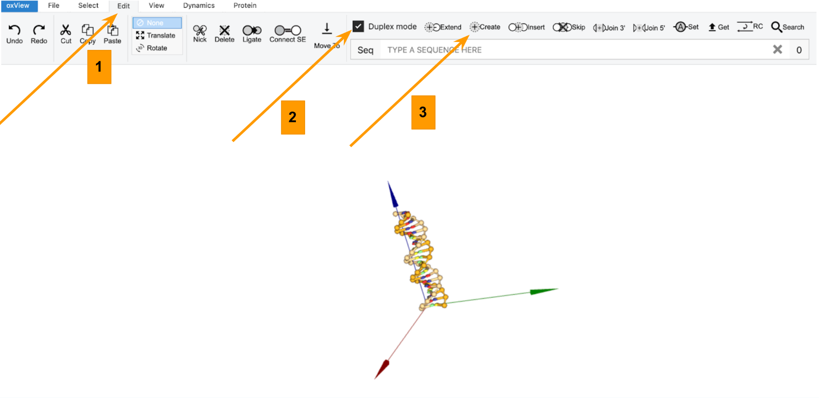
Fig. S2. DNA double-strand creation in oxView. Illustration of a DNA strand aligned with 3D axis vectors. The process involves activating “Edit” mode, enabling “Duplex mode” for complementary strand formation, and pressing “Create”.

Navigation within the simulated 3D space of oxView is managed using the mouse to seamlessly move across all dimensions. Users can zoom in and out through click-and-drag actions. On a Mac computer, zooming involves pinching two fingers together or spreading them apart. To re-position a DNA strand in the workspace, the “Box” option at the bottom of the screen is selected and used to draw a rectangle around the strand. The “Translate” option at the top of the screen can then be selected to trigger an axis to appear on the screen, aiding in further manipulation of the strand's position (Fig. S3).

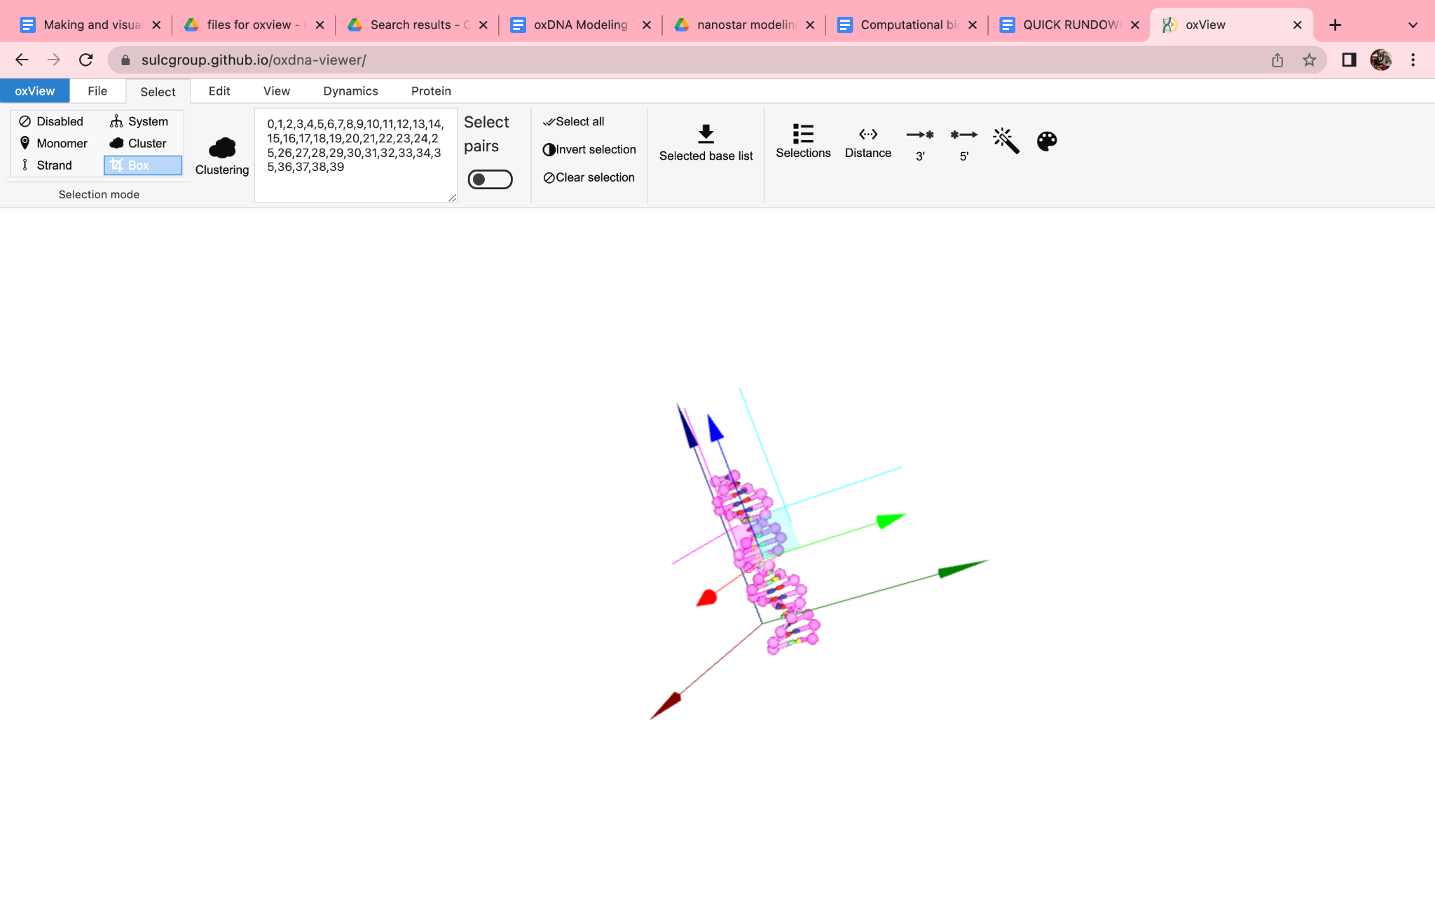
Fig. S3. Spatial adjustment of a double-stranded DNA structure in oxView. The structure is positioned at the intersection of the coordinate axes, ready for manipulation. Directional arrows indicate possible movements.

It is crucial to relocate the newly formed arm from its initial creation point, which serves as a common origin for all subsequent arms, to prevent overlapping. To facilitate this movement across the virtual space, first return to the “Monomer” mode at the bottom of the screen, then deactivate the selection by clicking “Clear selection” under the “Selection options” tab at the bottom of the screen. This action ensures the DNA strand is no longer selected, allowing for free movement without constraints (Fig. S4).

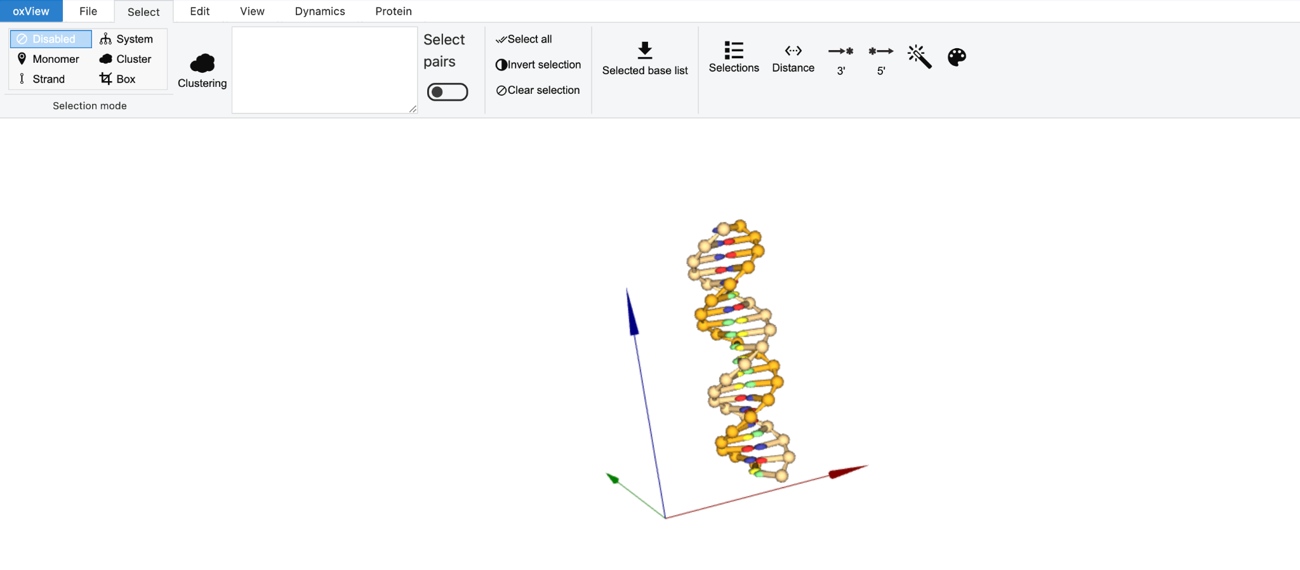
Fig. S4. DNA strand after disabling the selection to move across 3D virtual space freely.

Up to this point, the sequence in the underlined green font (Fig. S5, strand 4) was input into oxView. Because “Duplex mode” was selected, the reverse complementary bases (green font in strand 1 in Fig. S5) were automatically generated. This resulted in the modeling of one arm, formed by the complementary sequences of strand one and strand four. The color-coding system simplifies tracking these additions.

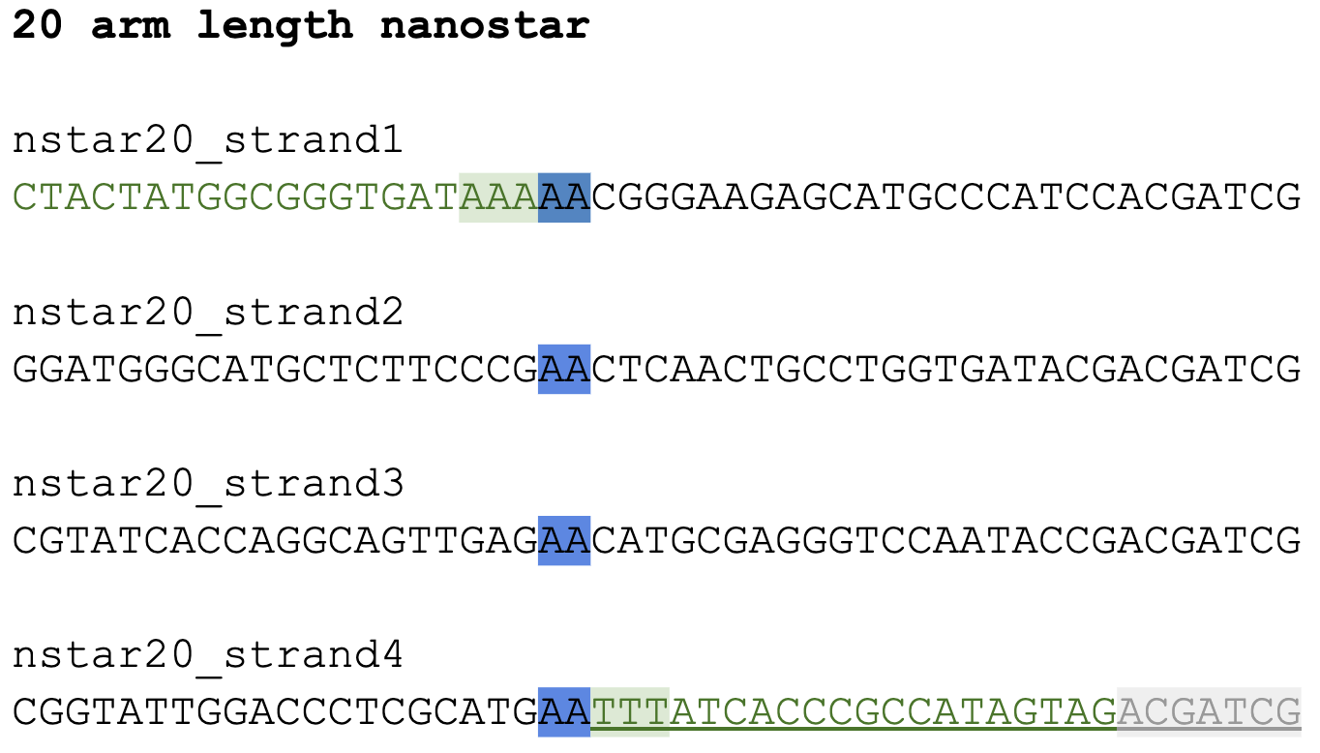

Fig. S5. DNA sequence representation for arm 1 of a 20 base-pair, 4-armed nanostar. The underlined green font in strand 4 indicates the bases manually entered into oxView. The corresponding green bases in strand 1 were automatically generated due to the selection of “Duplex mode”. Blue highlights mark the spacers, while the green highlights indicate the first complementary attachment point of arm 1. The sticky end of strand 4, which will be incorporated in the next step, is shaded in gray.
To construct a complete DNA nanostar arm, the addition of sticky ends and spacers is necessary (Fig. 1). The segments highlighted in blue (Fig. S5), referred to as spacers, and the sticky ends in gray—comprising an unpaired adenine followed by a six-nucleotide palindromic sticky end sequence [1]—were not initially included in the created DNA structure (refer to Fig. 1).
The first step is integrating the sticky ends. To do this, it is essential to identify the correct location and strand for attachment. In this case, the GAT sequence, which directly precedes the sticky end on the newly generated arm, is highlighted in red in Fig. S6. This sequence serves as the precise site for the sticky end addition, ensuring accurate structural assembly.
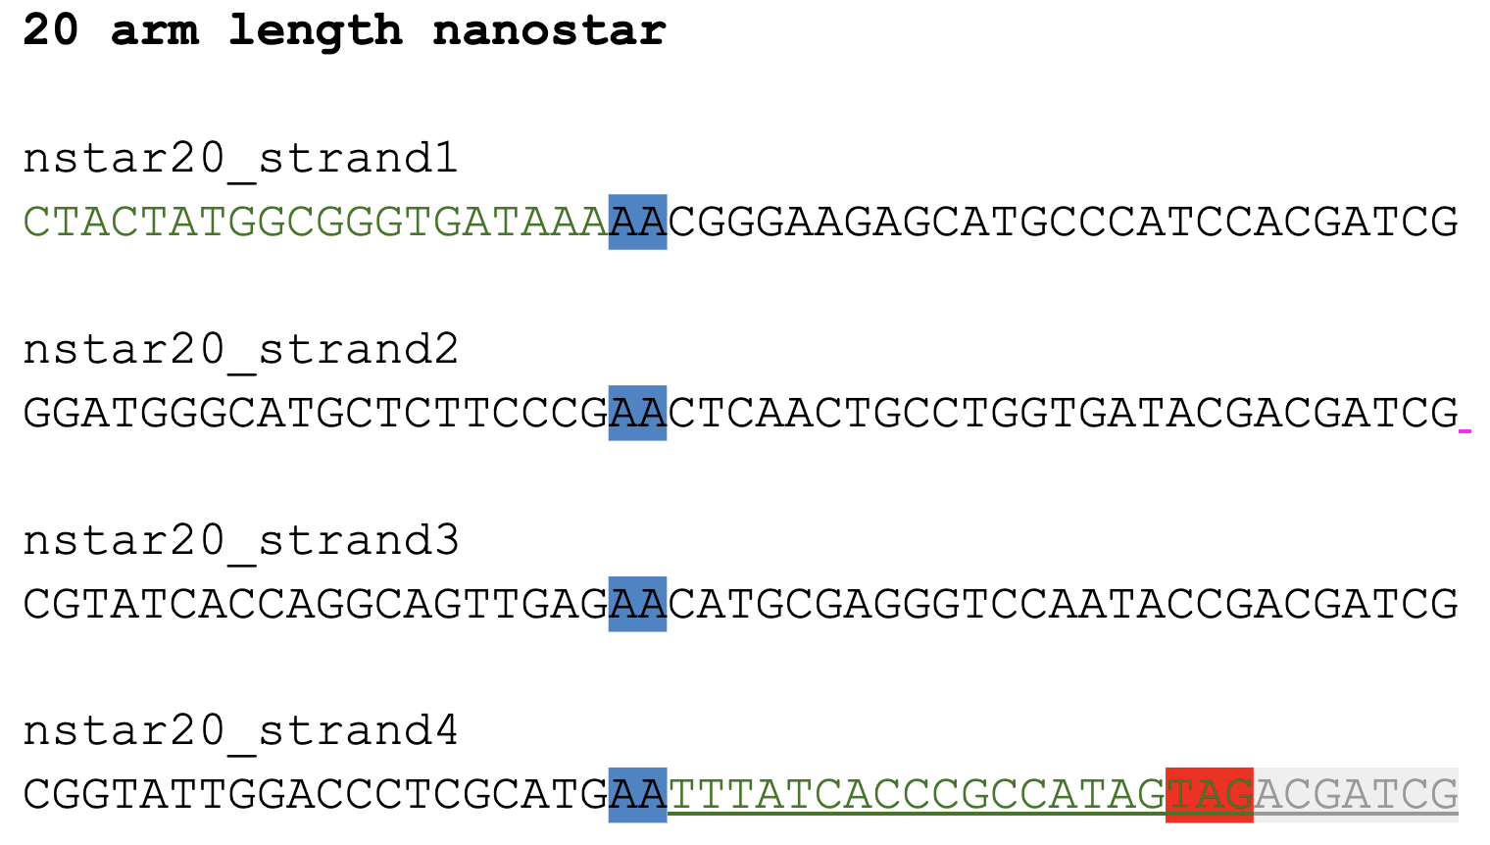
Fig. S6. Target sequence identification for sticky end addition in a 20-arm nanostar. The red-highlighted sequence "TAG," corresponding to "GAT" when read from the end of strand 4, marks the exact location for sticky end incorporation, ensuring proper DNA nanostar assembly.
To accurately locate the site for sticky end addition, the nitrogenous bases were examined by hovering the cursor over the yellow 'bubbles' representing individual bases in the oxView interface. This allowed for precise identification of the oligonucleotide sequence at the end of the DNA arm. In this instance, the sequence 'GAT' was located by reading sequentially from the strand’s end toward the middle, confirming the exact position for sticky end incorporation (Fig. S7).

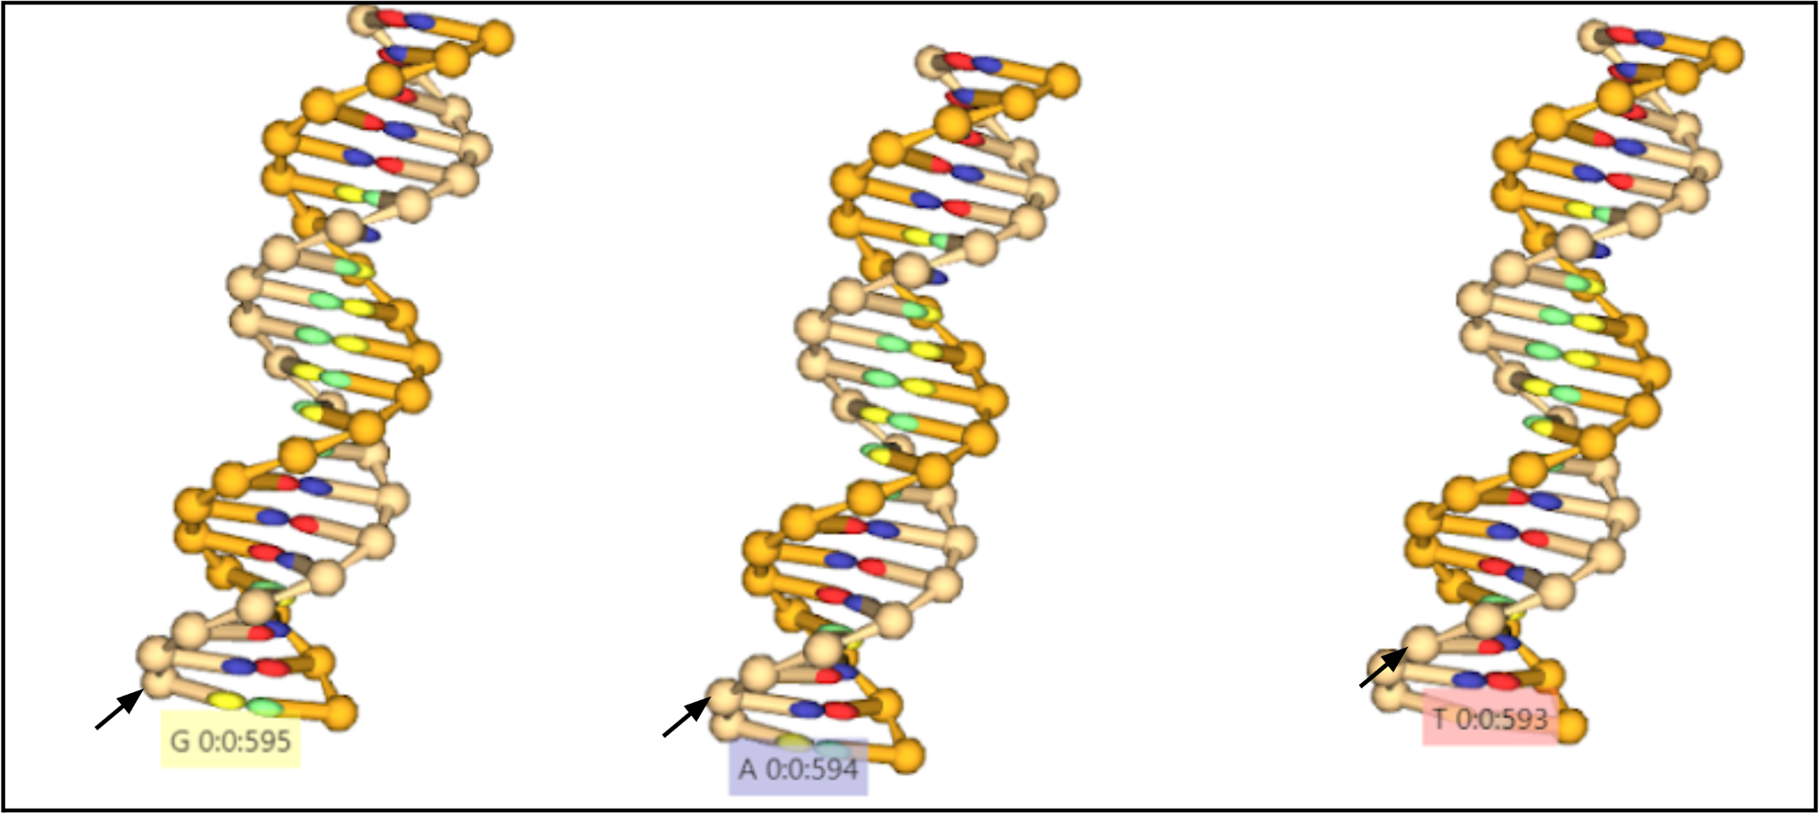

Fig. S7. Identification of the target sequence for sticky end addition in oxView. Black arrows highlight nitrogenous bases displayed as yellow 'bubbles' in the DNA model. The sequence 'GAT' is sequentially identified from left to right, marking the precise site where the sticky end sequence will be appended.

Once the appropriate end of the DNA arm and its corresponding strand were identified, the final base ('G') was simply selected by clicking on it within the “Monomer” mode. This action changed the base's color from yellow to pink, confirming its selection. Next, in “Edit” mode, the sticky end sequence ('ACGATCG') was entered into the "Seq" field. To ensure proper extension, "Duplex mode" was deactivated before clicking "Extend," resulting in an extended single-stranded sequence, as shown in Figure S8.

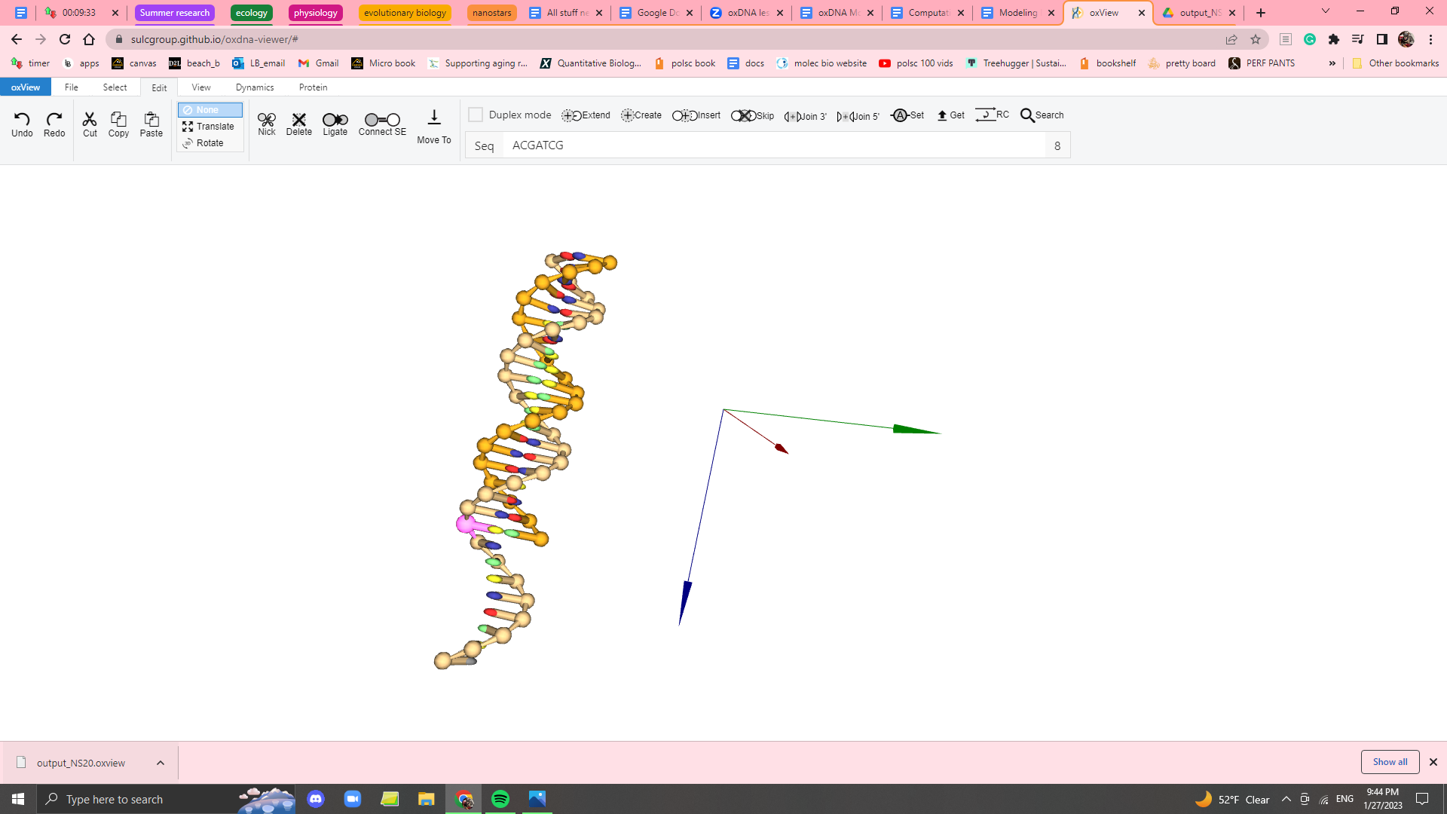

Fig. S8. Addition of sticky end sequence to DNA nanostar’s arm 1. The sticky end sequence ('ACGATCG') was successfully appended to the end of the first arm using the "Extend" function in oxView.

The process is then repeated to add the spacers (SP), represented as AA bases highlighted in blue (Fig. S6). Similar to the sticky end addition, the correct strand must be identified by hovering over the ‘bubbles’ to ensure precise placement of the spacers.

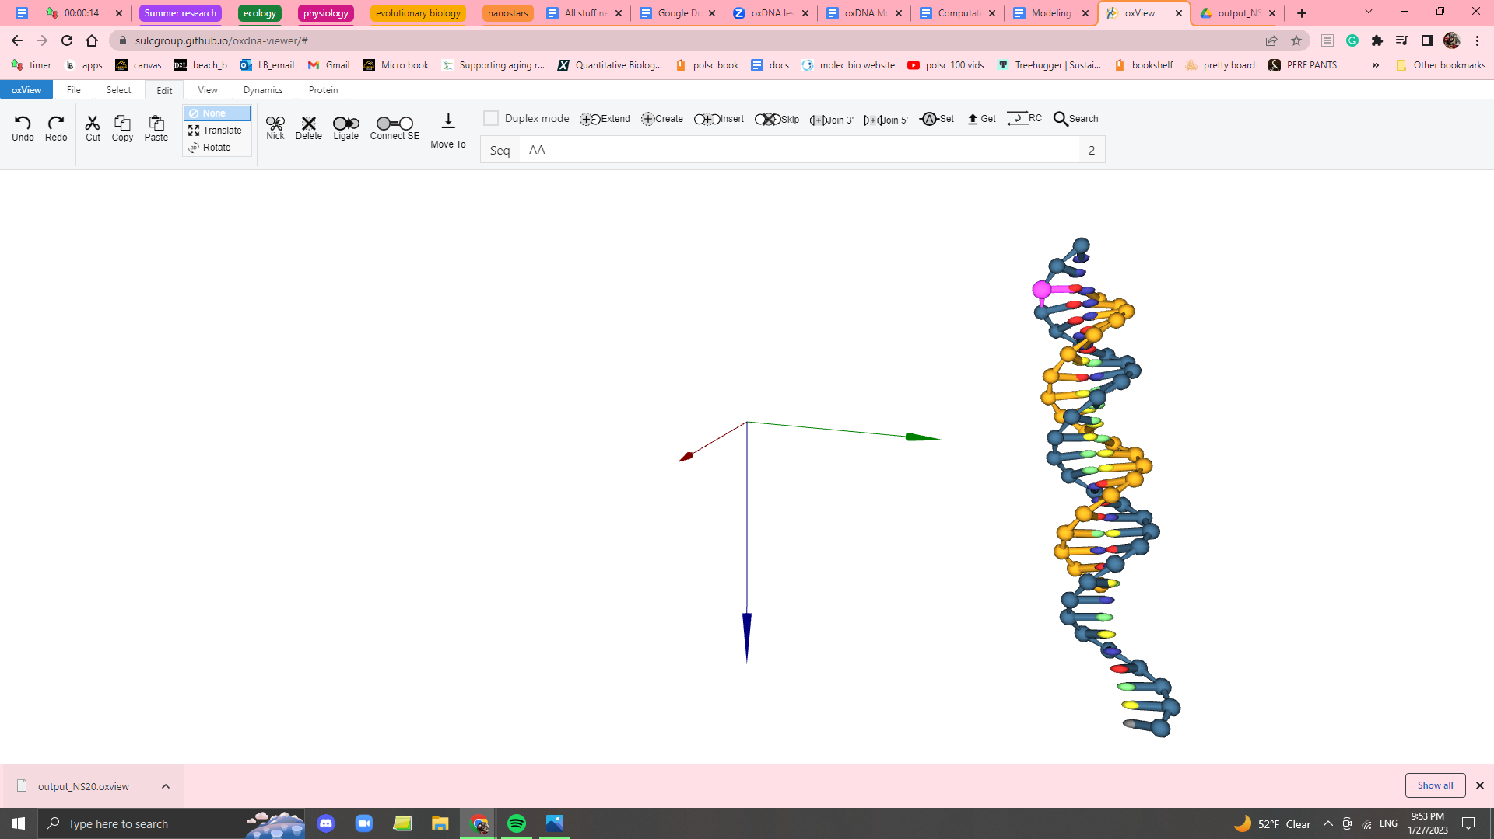
Fig. S9. Finalized DNA arm with spacer addition. The modeled first arm of the nanostar after incorporating the AA spacer sequence. The spacers play a crucial role in defining the nanostar’s flexibility and structural integrity.
With the successful creation of the first arm, the remaining three arms can now be added by repeating the same steps for each corresponding strand. Utilizing the suggested color-coding system ensures an efficient and organized workflow, simplifying the repetitive process.
At this stage, all necessary components for assembling the DNA nanostar are complete. The next step involves correctly orienting and connecting the arms to form the final nanostar structure. As this step requires careful alignment, the following instructions provide a detailed, step-by-step guide to ensure accuracy.
To facilitate preliminary organization, it is beneficial to position the arms such that the spacers face the center, thus forming a pseudo-nanostar (Fig. S10). The workspace is visualized as divided into four quadrants, with each arm assigned a specific quadrant. Once the arms are organized—with sticky ends directed outward and spacers facing inward—the next step is to ligate the arms. This process begins by identifying a spacer region (the AA double) and tracing the bases to confirm the correct strand for ligation.

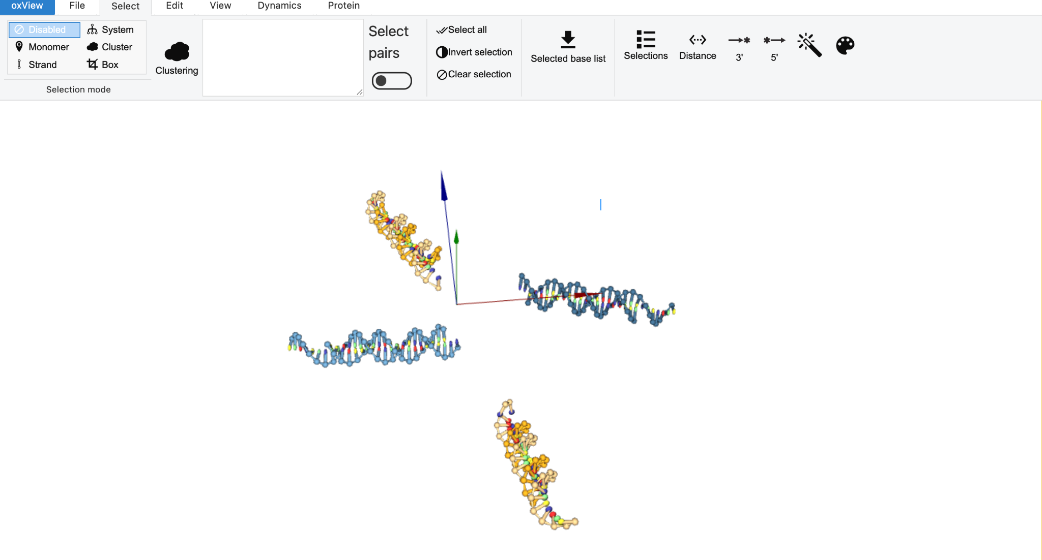
Fig. S10. DNA nanostar arms positioned in 3D space for assembly. The four arms are arranged with their sticky ends facing outward and spacers directed inward, ensuring proper orientation before the ligation step. The spatial distribution helps visualize their relative positions

For instance, if a spacer is examined and the three bases following it (toward the sticky ends) are identified as CTC, it is determined that the strand being worked on is strand two. This strand must then connect to GCC, which is part of another arm created from strand 1 as the complement. These bases are highlighted in yellow for easier tracking (Fig. S11).

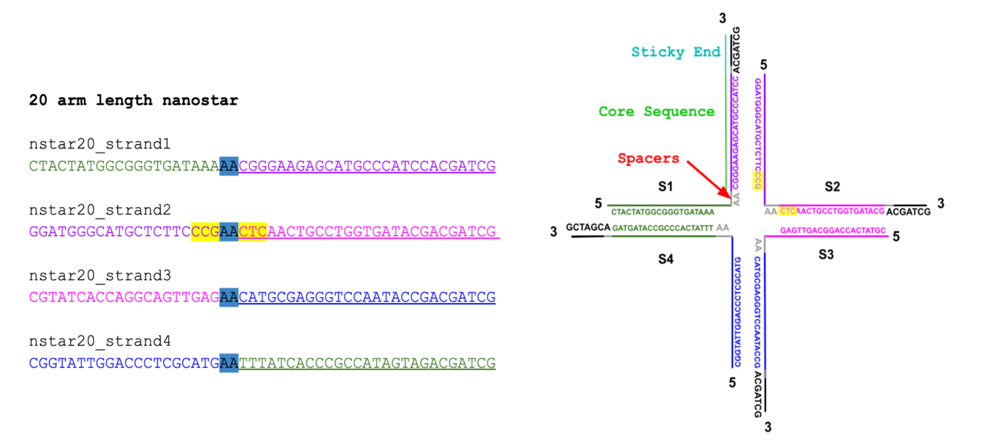
Fig. S11. Identification of ligation sites based on highlighted bases. The bases highlighted in yellow in both the sequence list (left) and the 2D schematic (right) indicate the ligation site.

The sequence GCC is then located, and the outermost nucleotide (‘G’ in this case) is selected within the "Monomer" mode. While holding the "Ctrl" or "Command" key, the last ‘A’ of the spacer is also selected. Once both bases turn pink, the "Ligate" option is clicked, forming a covalent bond between the two bases (Fig. S12). This process is repeated for all arms to fully assemble the DNA nanostar, ensuring each strand is correctly joined at the designated ligation sites.

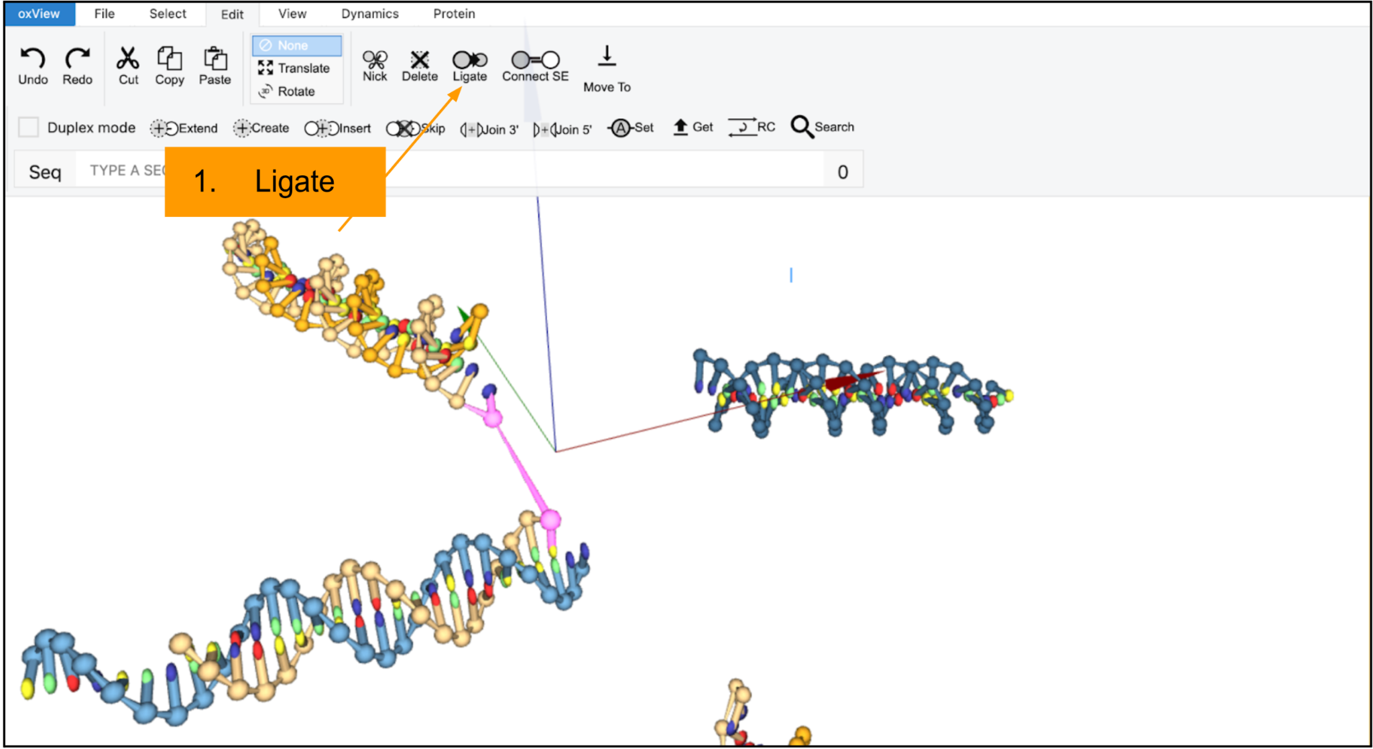
Fig. S12. Ligation of DNA nanostar arms. The image illustrates the ligation process in oxView, where the selected nucleotide ('G') from one arm and the spacer ('AA') from another are highlighted in pink. The ligation function, marked with an orange label, is used to covalently bond these bases, forming a continuous DNA strand.

This process is repeated for the remaining strands to fully assemble the nanostar. To optimize structural stability, the strands are relaxed by bringing them into close proximity (Fig. S13). This step minimizes spatial gaps between ligated arms, reducing computational processing time when uploading the model into oxDNA for analysis.

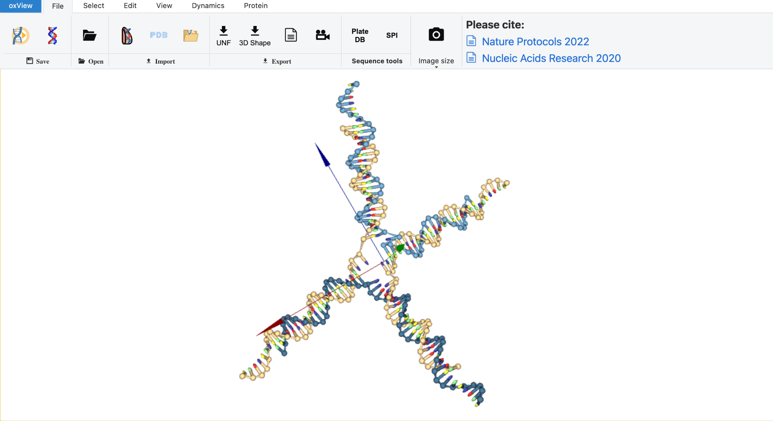
Fig. S13. DNA nanostar after manual relaxation. The assembled nanostar is adjusted by reducing strand separation to enhance structural stability. Relaxation improves model cohesion and prepares the structure for computational analysis in oxDNA.

The .top and .dat files necessary for oxDNA submission are downloaded by clicking the “oxDNA” icon in the “File” tab (Fig. S14).

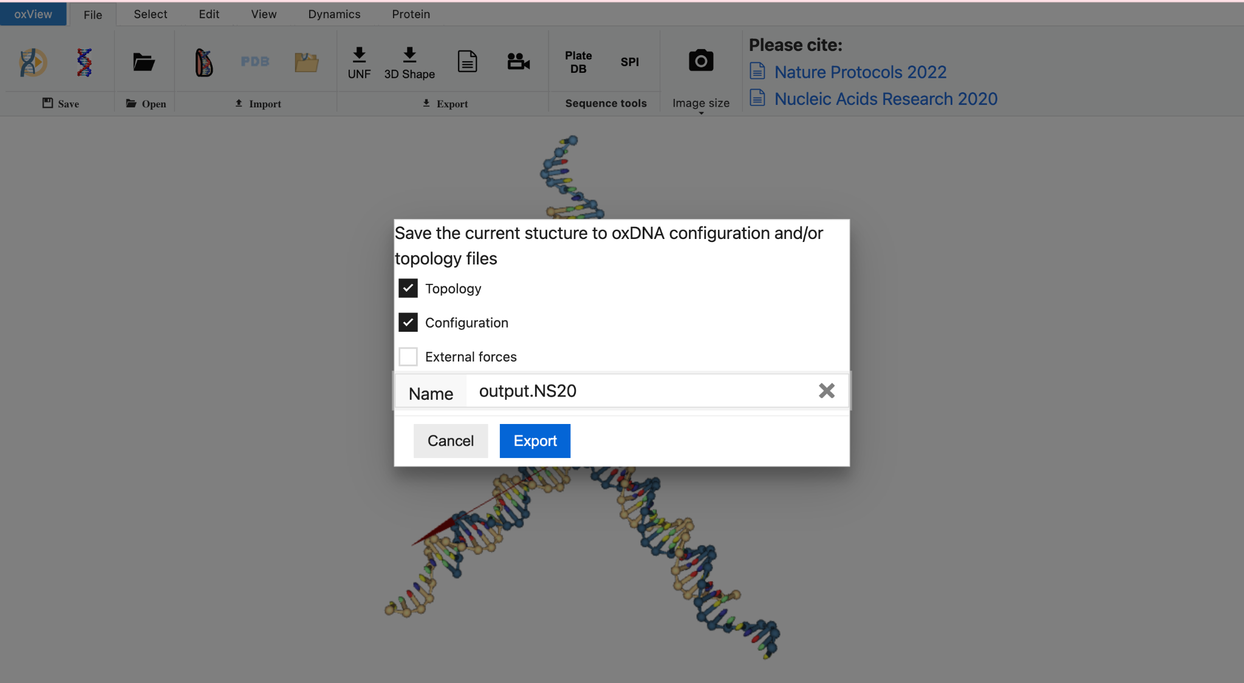
Fig. S14. Downloading .dat and .top files on oxView for oxDNA input of the finished nanostar.
The topology and configuration files are uploaded to the oxDNA website under the “Create a Job” option. This process could be performed as a guest. A temperature setting of 27 °C was selected to reflect typical laboratory conditions. Before submission, the “Needs Relax” option was enabled to ensure structural equilibration.
Extending the Sequence for the G-tetraplex to Arm 4 of the DNA Nanostar

To add the chosen DNAzyme sequence, it was first necessary to identify the side of the fourth arm where the sequence needed to be added (Fig. S15, indicated by the arrow).

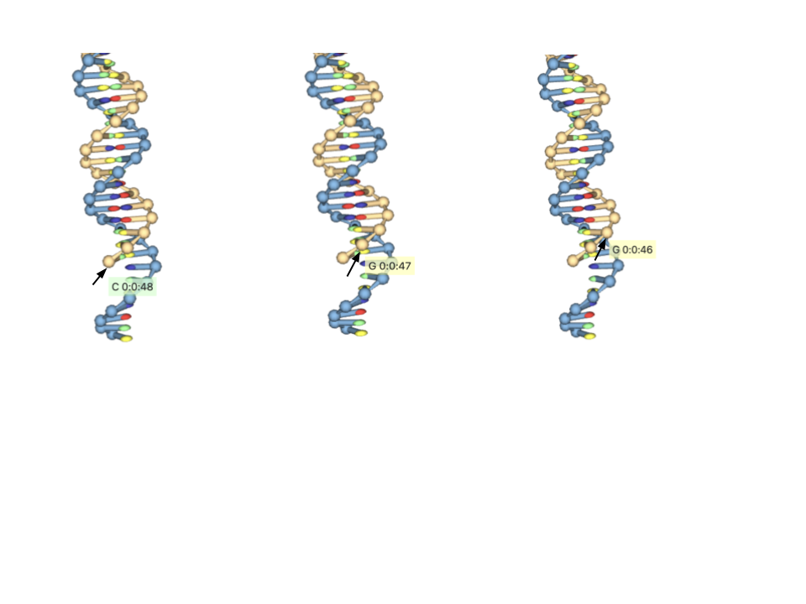
Fig. S15. Successfully identified base for DNAzyme addition.

The cursor was moved over the bubbles to locate the correct sequence, as these bubbles symbolized the nitrogenous bases on the DNA (Fig. S15). In this case, the sequence CGG was identified, starting from the end and moving toward the middle (the highlighted red sequence, Fig. S16).

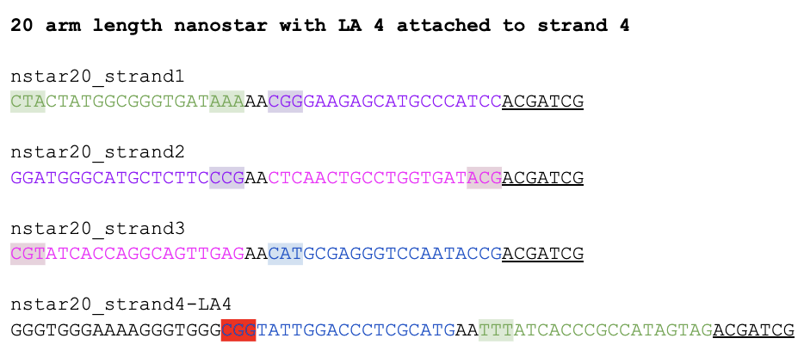

Fig. S16. Identification of sequence for DNAzyme addition as highlighted in red.

Even though the correct end of the arm and the corresponding strand were identified, the DNAzyme sequence was not added directly to the nanostar. Instead, the goal was to add the sequence near the end of the fourth arm where it would later be attached. The purpose of avoiding direct attachment to the CGG sequence was to avoid oxView attaching or binding the DNAzyme sequence to the sticky ends on the other strand. Although these bases would theoretically separate again upon oxDNA simulation, this step is taken to relax the model as much as possible before input into oxDNA.

The process consisted of returning to "Edit," where the DNAzyme sequence (written in black before the sequence highlighted in red in Fig. S16) was copied and pasted into "Seq." "Duplex mode" was deselected, and "Create" was clicked. The resulting output displayed a single-stranded sequence added nearby to arm 4 (Fig. S17).

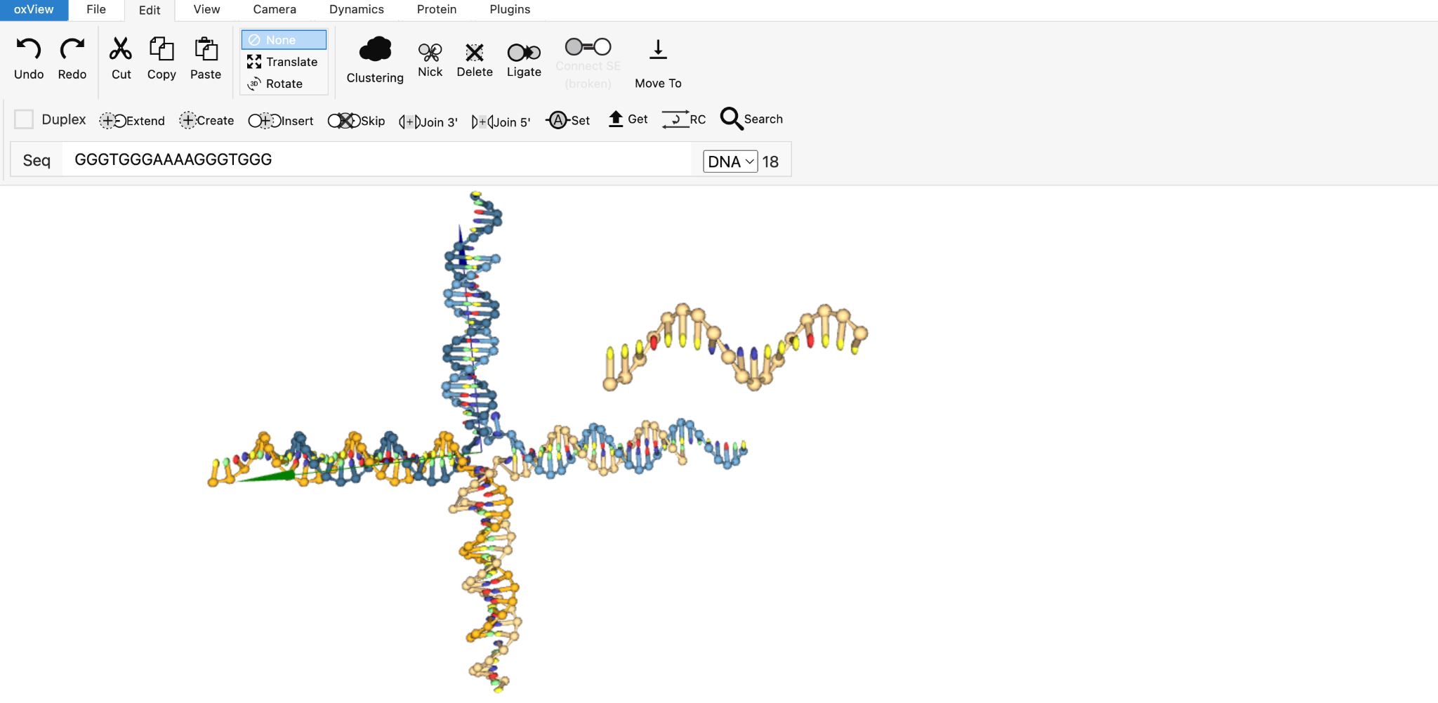

Fig. S17. Successful addition of the DNAzyme sequence near arm 4.

The newly added DNAzyme sequence was then selected by clicking on "Box,” drawing a rectangle over the sequence, and then returning to "Monomer" mode. The selected bases changed color, turning from its original yellow to pink, indicating successful selection (Fig. S18). The selected sequence was then moved closer using the “Translate” and “Rotate” buttons to the CGG sequence to which it would be added, making sure that bases that were to be joined matched the sequence order in Figure S16.

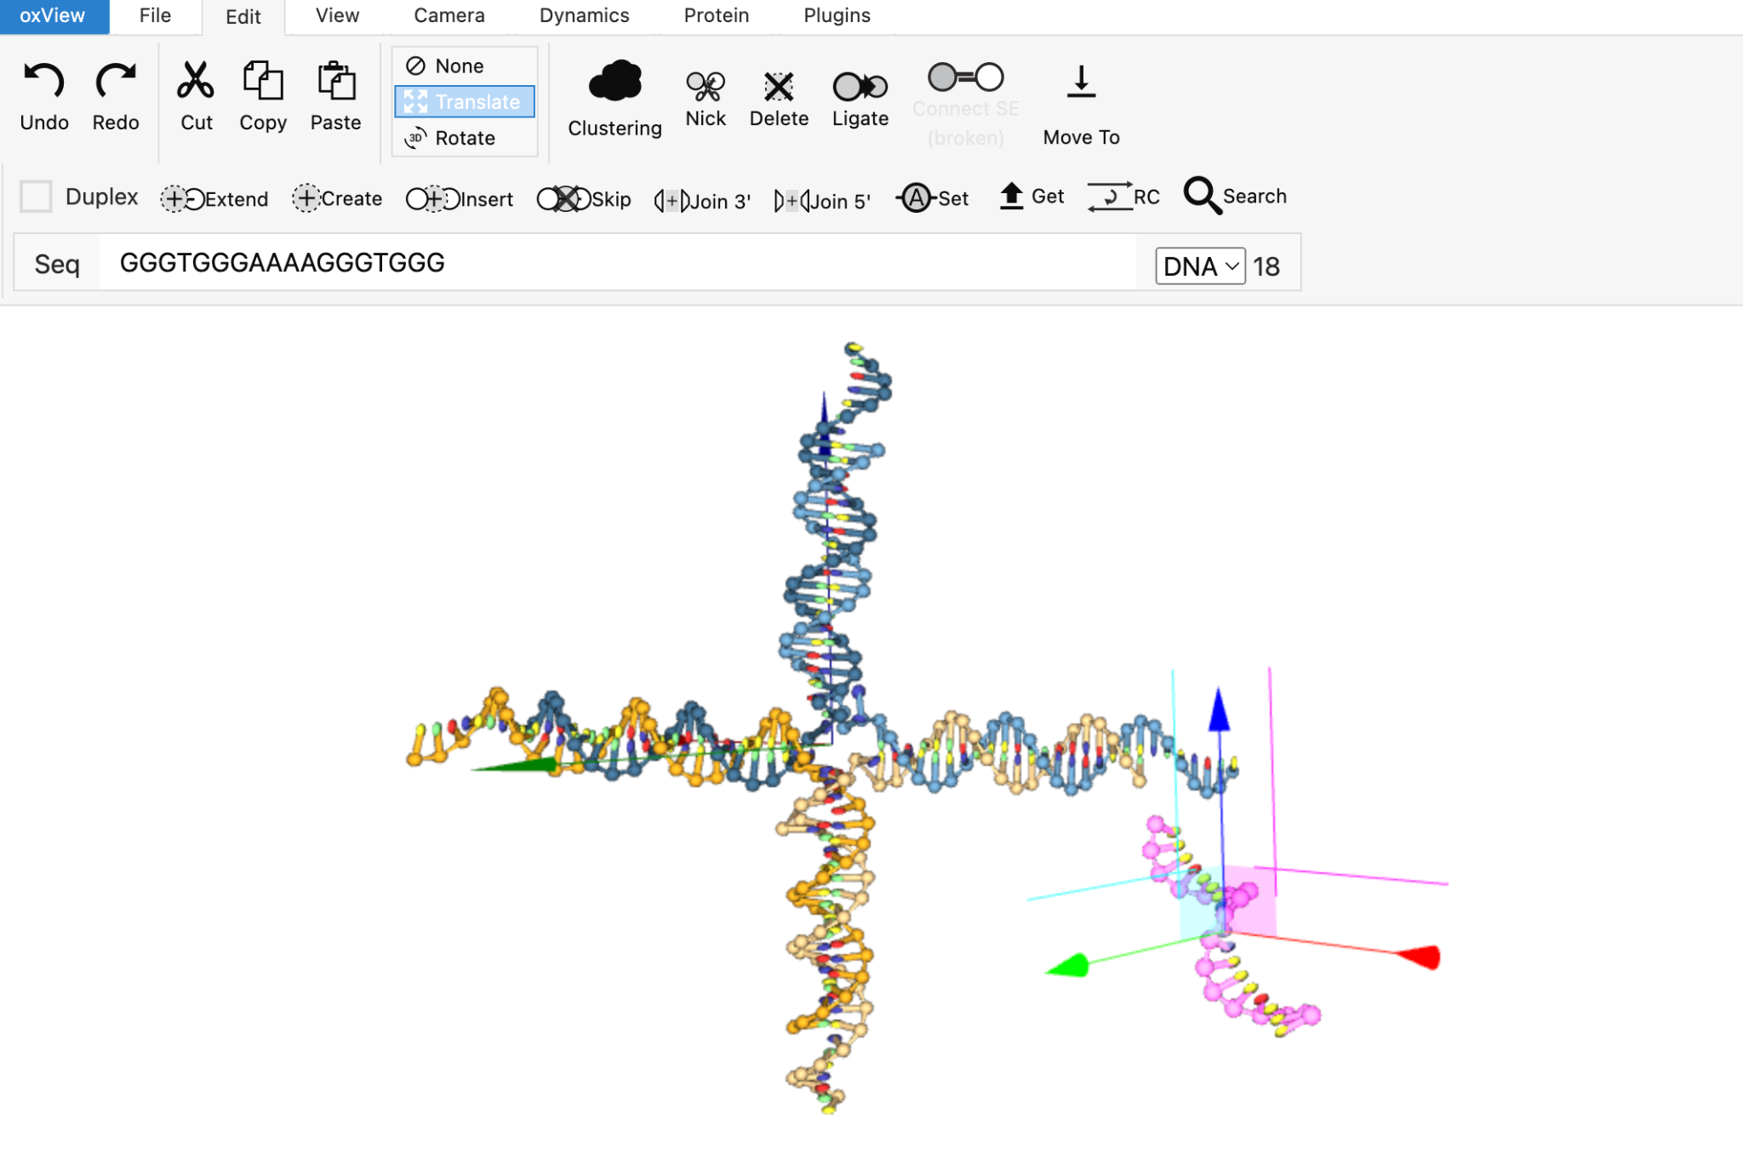
Fig. S18. DNAzyme sequence rearranged for less complicated ligation.

The selected sequence of the DNAzyme was then deselected using the arrow button in the toolbar to “Clear selection.” Then, the sequence CGG that was already located was returned to, and the last base of the fourth arm of the nanostar (‘C’ in this case) was selected under "Monomer" mode and, while holding the "Ctrl" or "Command" key, the last ‘G’ of the DNAzyme was also selected. Once both bases turned pink, the "Ligate" option was clicked to form the covalent bonds joining the bases together (Fig. S19).
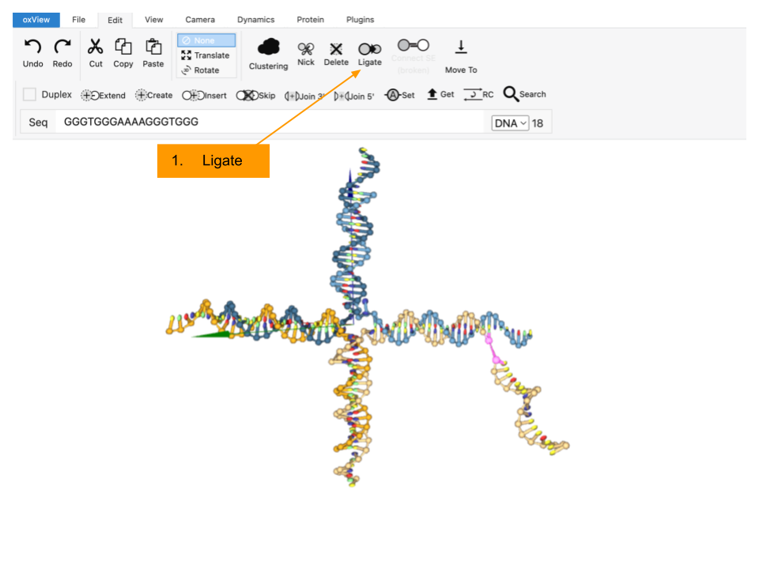

Fig. S19. Ligated arms (GGG-CGG). The image illustrates the ligation process in oxView, where the selected nucleotide ('C') from the fourth arm of nanostar 20 and the last selected nucleotide of the G4 (LA4) sequence ('G') are highlighted in pink. The ligation function, marked with an orange label, is used to covalently bond these bases, forming a continuous DNA strand.
Again, the structure was relaxed by selecting and bringing the DNAzyme sequence as close to the CGG sequence of the fourth arm as possible (using the “Translate” and “Rotate” buttons) without binding to the other strand of arm 4 (Fig. S20), which reduced the waiting time for uploading the model into the program used to analyze the DNA nanostar–oxDNA.
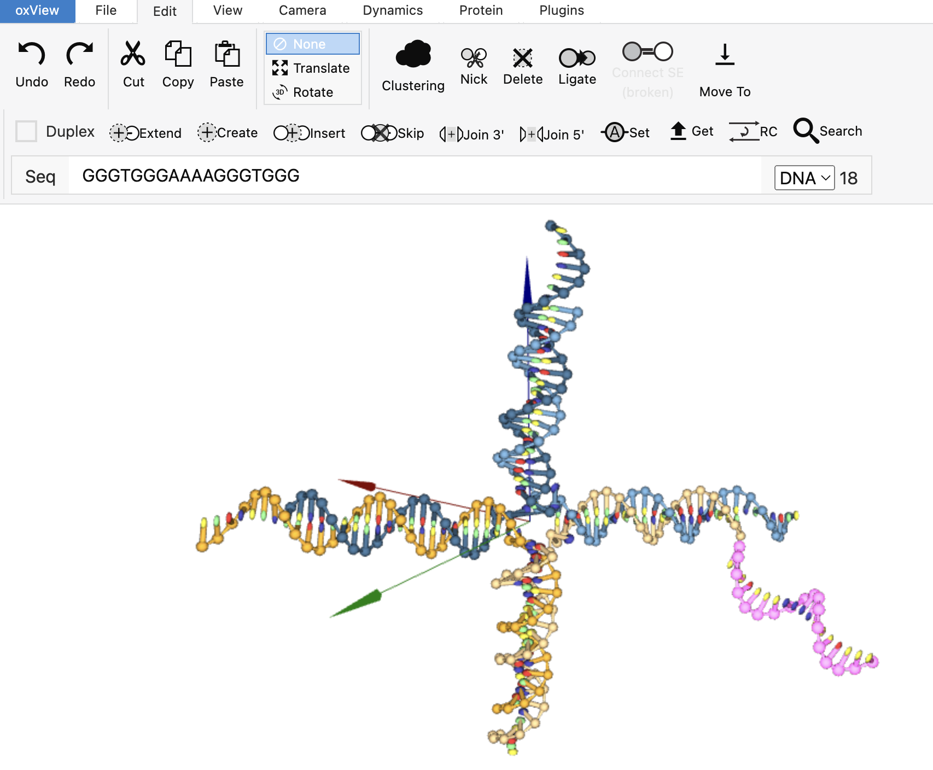

Fig. S20. DNA nanostar 20 with LA4 attached is relaxed by manual DNAzyme shifts.

To simulate the folding of the DNAzyme into a quadruplex structure, however, an additional step is required. When creating .dat and .top files from oxView to input into oxDNA (Fig. S14), there is also the option to create an external force file, which must be exploited here. An external force file is a way for oxDNA users to create tension on the DNA structure and/or to accelerate the process of forming a secondary or tertiary structure [2]. To implement this same force on the DNAzyme, the sequence was again selected as a whole using the “Box” function in the toolbar then returning to “Monomer” mode. The steps for adding the forces on oxView are as follows: “Dynamics” mode was selected and the "Forces" button was chosen. Upon selection, a pop-up appears with a few options and information given. Here, stiffness was increased to 8.09 to promote folding [3] and the button for “Create from selection” was clicked (Fig. S21).
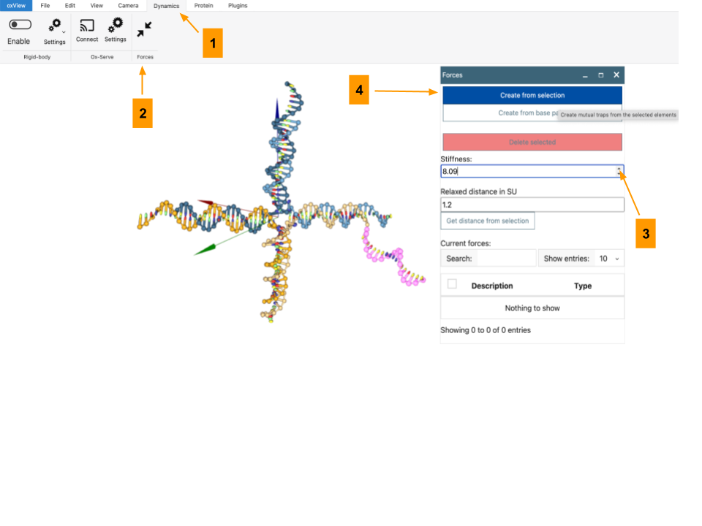

Fig. S21. Applying external forces to the DNAzyme with oxView.
After exiting this pop-up screen, the applied forces should be visible on oxView (Fig. S22).

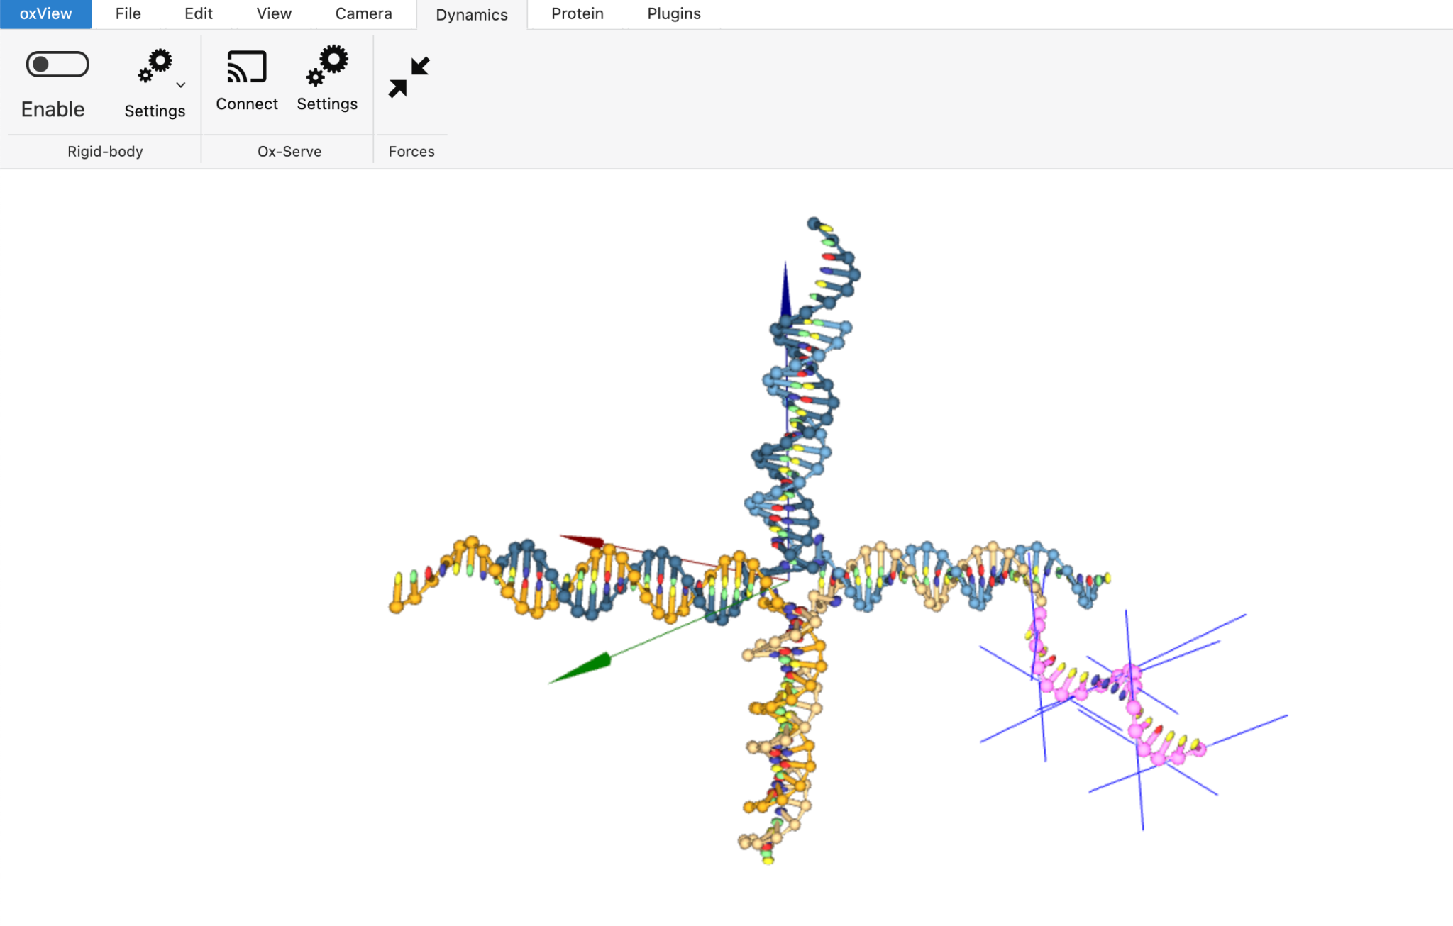

Fig. S22. External forces acting on the DNAzyme in oxView.

The .top, .dat, and external files were now downloaded from oxView (Fig. S23) and uploaded into oxDNA.

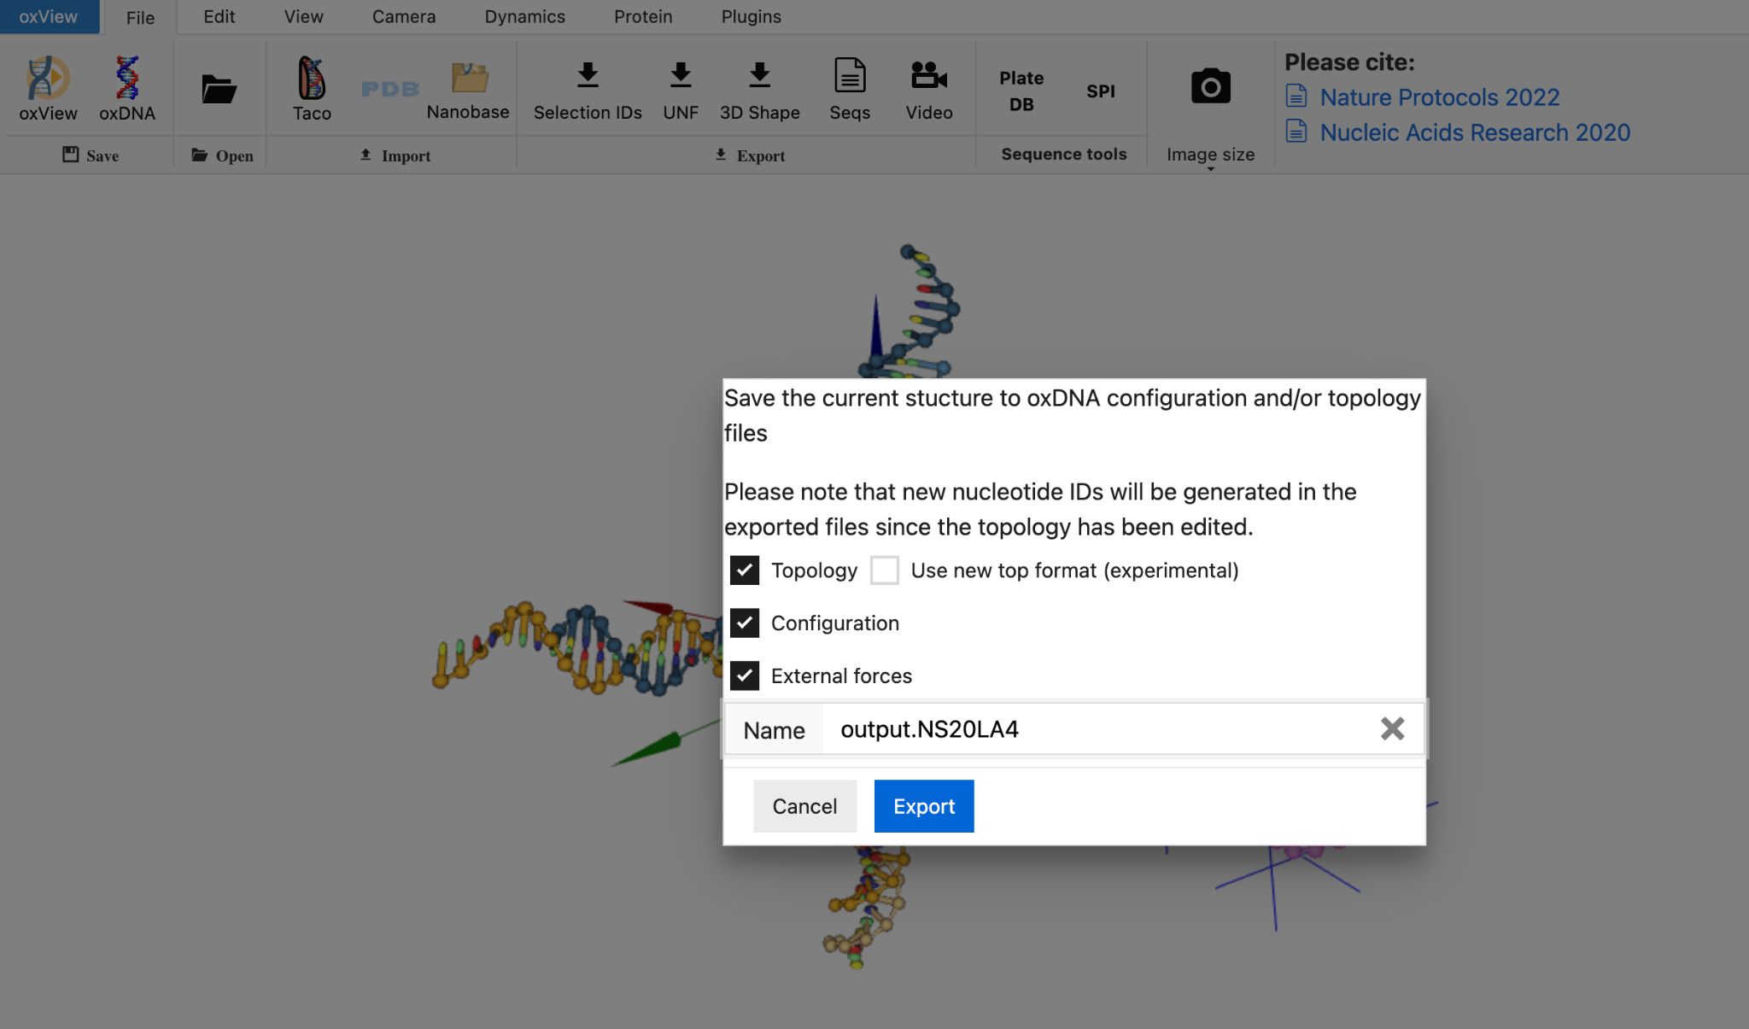

Fig. S23. Downloading .dat, .top, and external files for oxDNA inputs.

A temperature of 27 °C was selected, the "Needs Relax" button was checked, and the external force file was chosen under the “View advanced parameters” button before submitting the job.

Table S2. Forming NS15/50% 5xG3T Reaction Mixture (Positive Control)
Reagent | Initial Concentration (µM) | Final Concentration (µM) | Volume Added (µL)
nstar15_strand1 | 97.3 | 19.00 | 9.76
nstar15_strand2 | 93.4 | 20.00 | 10.71
nstar15_strand3 | 90.1 | 20.00 | 11.10
nstar15_strand4 | 92.5 | 10.00 | 5.41
nstar15_strand4-5xG3T | 181 | 10.00 | 2.76
KCl (mM) | 2000 | 350.00 | 8.75
trisHCl (mM) | 200 | 20.00 | 5.00
milliQ water | –– | –– | 15.46
Total Volume | –– | –– | 50.00
*Initial concentrations for strands 1-4 (excluding strands with 5xG3T) are based on concentrations after a tenfold dilution.
**Table adapted from ref. 5 (under review).

Table S3. Volumes of Reagents Used in NS15/50% 5xG3T Peroxidation Reaction

Reagent | Concentration | Volume
Hemin | 50 uM in 1X rxn buffer | 6 uL
ABTS | 6 mM in 1X rxn buffer | 10 uL
Reaction buffer | 1X | 70 uL
H₂O₂ | 6 mM in 1X rxn buffer | 10 uL

Table S4. Preparation of 10 mL of 2X Reaction Buffer
Reagent | Concentration | Volume
Tris-HCl | 1 M | 200 uL
KCl | 2 M | 1mL
DMSO | — | 200 uL
Triton X-100 | — | 10 uL
dH₂O | — | 8.59 mL

Table S5. Preparation of 10 mL of 1X Reaction Buffer
Reagent | Concentration | Volume
rxn buffer | 2X | 5 mL
dH₂O | — | 5 mL

Table S6. Preparation of 2 mL of 6 mM Hydrogen Peroxide in 1X Reaction Buffer
Reagent | Concentration | Volume
rxn buffer | 2X | 1 mL
H₂O₂ | 30% (w/w) (=9.79M) | 1.23 uL
dH₂O | — | 998.8 uL

Table S7. Preparation of 2 mL of 6 mM ABTS in 1X Reaction Buffer
Reagent | Concentration | Volume
rxn buffer | 2X | 1 mL
ABTS | 18.226 mM | 658 uL
dH₂O | — | 342 uL
*A stock concentration of 18.226 mM ABTS was achieved by dissolving 5 tablets of ABTS in 5 mL of dH₂O and vigorously vortexing the tube.

Table S8. Preparation of 2 mL of 50 uM Hemin in 1X Reaction Buffer
Reagent | Concentration | Volume
Tris-HCl | 1 M | 20 uL
KCl | 2 M | 100 uL
Hemin in DMSO | 5 mM | 20 uL
Triton X-100 | — | 1 uL
dH₂O | — | 1.859 mL
*A stock concentration of 5 mM hemin was achieved by dissolving 6.52 mg of hemin in 2 mL of DMSO and mixing the tube.
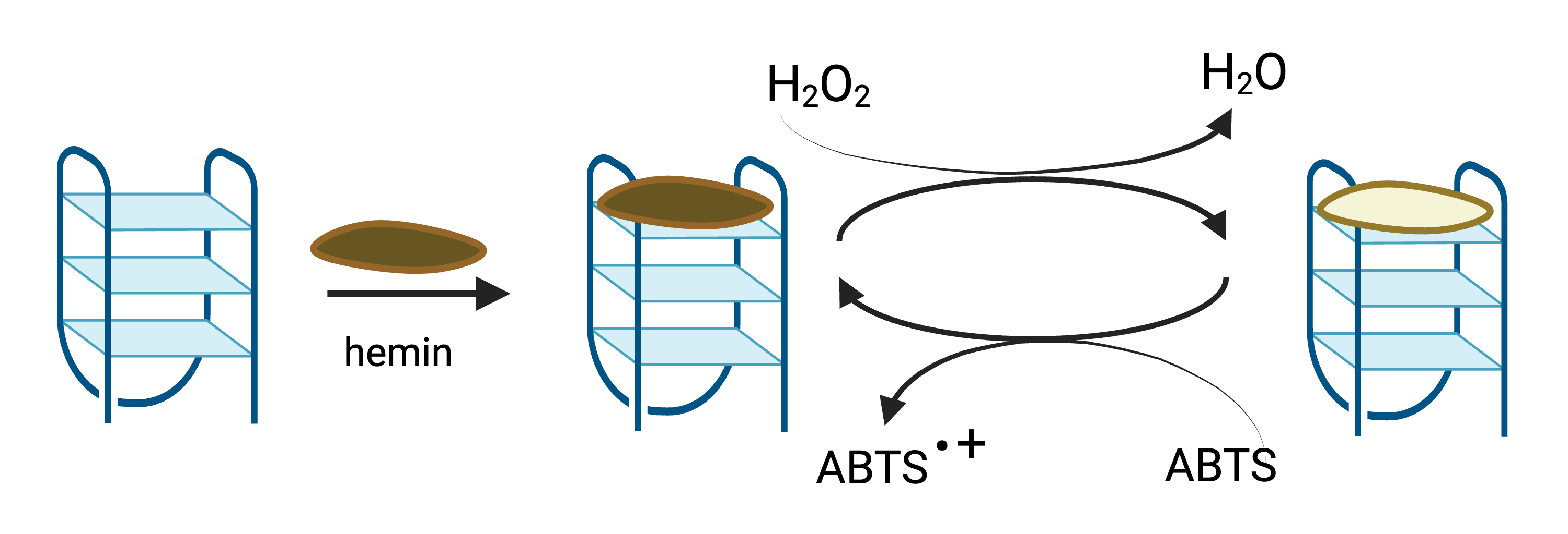

Fig. S24. DNAzyme-catalyzed peroxidation. “G4” G-tetraplex structure which, when hemin is bound, becomes a peroxidase that uses H₂O₂ to oxidize the colorimetric substrate ABTS, which turns a blue-green color [4,5; Adapted from ref. 6]. Created using BioRendr.com.

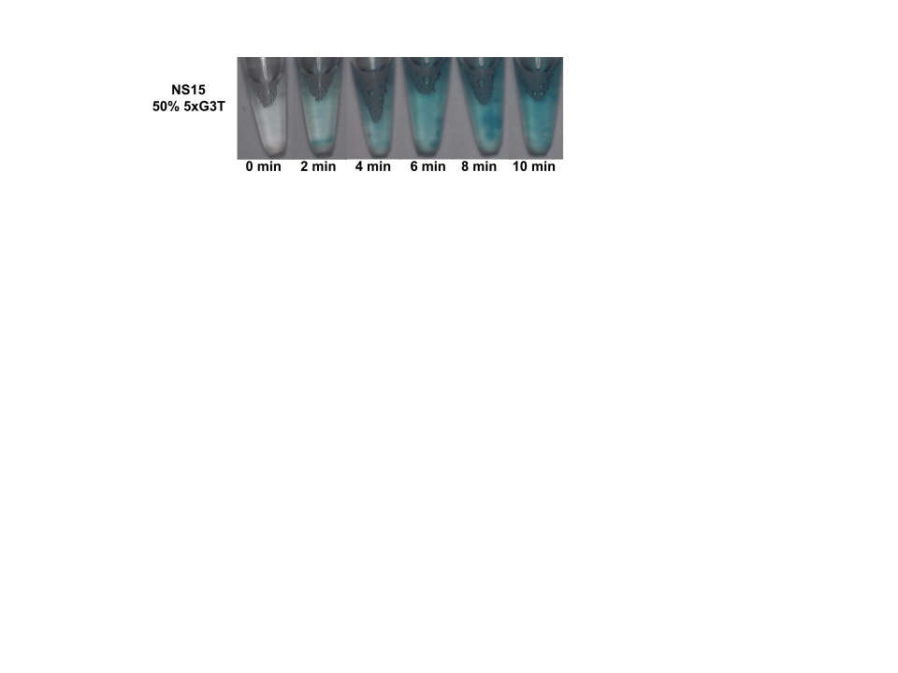
Fig. S25. DNAzyme-catalyzed peroxidation reaction in a single nanostar 15 layer system on the microscale. The reaction tube consisted of all four strands of nanostar 15 (Table S1), with 50% of strand 4 also including the 5xG3T DNAzyme. The nanostars were annealed by heating to 95°C for ten minutes, then cooling slowly to room temperature at a rate of 1°C/min in a thermocycler, after which hemin, ABTS, and hydrogen peroxide substrates were added to the reaction tube. The progression of the reaction (evidenced by a blue color change) was recorded every 2 minutes over a 10-minute interval using a UHM-350 camera microscope at 1.5X resolution. This reaction was at the core of our in vitro experimentation, and its component nanostars were at the center of in silico experimentation attempts to better understand how the reaction takes place at the molecular level [Figure and experimental found in ref. 5].

Modeling DNA Nanostars with oxDNA and oxView: student worksheet

We will use a program called oxView to “draw” a DNA nanostar, followed by a program called oxDNA to simulate the DNA nanostars; this can give us insight into the structure, dynamics, and energetics of these DNA nanostars. Below is an example of a DNA nanostar, 2 different snapshots, modeled with oxView.

Snapshot of oxView Model of NS-20, a 4-arm, 20 base pair DNA nanostar:
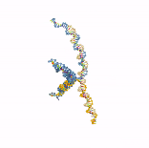

For a dynamic GIFs of DNA nanostars, see the following on YouTube:
- Dynamic GIF of 4 armed nanostars created on oxView and simulated using oxDNA. https://www.youtube.com/watch?v=G_R1Yf2wMC8 [4 arm, 15 base pair / arm DNA nanostar]
- Dancing DNA nanostar! https://www.youtube.com/watch?v=fzsTfnswbB8 [4 arm, 20 base pair/arm DNA nanostar]

Relevant websites to access these programs:

Here is the oxDNA dashboard: https://oxdna.org/

Here is the oxView website to draw your DNA nanostar: https://sulcgroup.github.io/oxdna-viewer/

Today’s lab:

You will use the tutorial video and step-by-step guide to model your assigned DNA nanostar!

You can work in your groups on this assignment, and you will have one week to submit the results on Canvas.

Group Assignments of DNA nanostar you will model and corresponding DNA strands.

Group 1 | NS-15

15 arm length DNA nanostar

nstar15_strand1C
CTAGTCTACAGTGCCAACTGGGCAGAATTCCCAGCTAGC

nstar15_strand2
GGGAATTCTGCCCAGAACGTCACCAGAAGCACAGCTAGC

nstar15_strand3
GTGCTTCTGGTGACGAAGACGGAATCTCCGTCAGCTAGC

nstar15_strand4G
GACGGAGATTCCGTCAAGGCACTGTAGACTAGAGCTAGC

Group 2 | NS-20

20 arm length DNA nanostar

nstar20_strand1
CTACTATGGCGGGTGATAAAAACGGGAAGAGCATGCCCATCCACGATCG

nstar20_strand2
GGATGGGCATGCTCTTCCCGAACTCAACTGCCTGGTGATACGACGATCG

nstar20_strand3
CGTATCACCAGGCAGTTGAGAACATGCGAGGGTCCAATACCGACGATCG

nstar20_strand4
CGGTATTGGACCCTCGCATGAATTTATCACCCGCCATAGTAGACGATCG

Group 3 | NS-25

25 arm length DNA nanostar

nstar25_strand1
CGCTACAATACAGTTACAAGAATGCAACGCTTGATGTATGCACGTATGTTGCACACGTG

nstar25_strand2
GCAACATACGTGCATACATCAAGCGAACATATCTCATATTCGTGCCACTATGACACGTG

nstar25_strand3
CATAGTGGCACGAATATGAGATATGAACAGTAGGGCAGCAAAGACTACGGTGACACGTG

nstar25_strand4
CACCGTAGTCTTTGCTGCCCTACTGAAGCATTCTTGTAACTGTATTGTAGCGACACGTG
How to color code your DNA strands.

Color-coding your DNA stands will help with your modeling. We have helped you by coloring the sticky ends and the spacers on each strand. We have also underlined the bases that must be copied into the oxView program. The next step would be performed by you! You must identify which section of a strand corresponds to each other. To do this you must remember the pairing of the nitrogenous bases of DNA (hint; A-T and C-G); an example can be seen below.

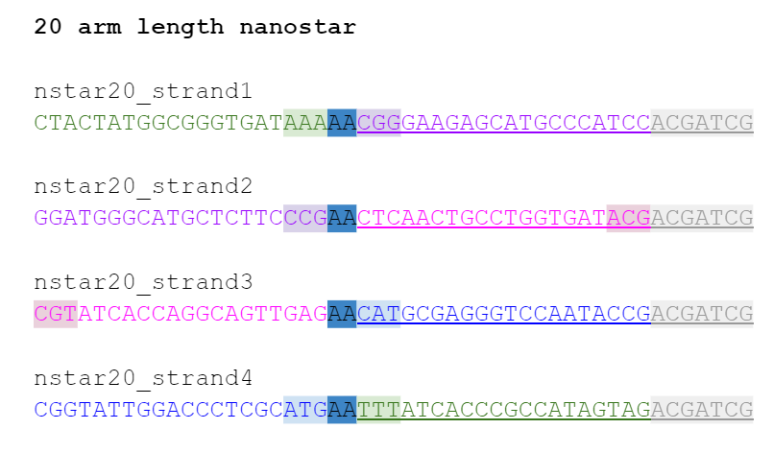
All purple color bases will connect to each in accordance to the correct base pairing. This gives rise to strands connecting between each other. By the individual strands adhering together you create a system of arms.

Instructions

You will use this YouTube tutorial video, the step-by-step written tutorial, this presentation, and your DNA strands to model your assigned DNA nanostar. You should create a Zoom link for your group and all log in at a particular time on Wednesday (i.e. during our lab period!) and then you can work on the model together. You are also welcome to meet up in person and all follow along on one laptop. You only need 1 submission per group. Be sure to clearly label everything with your group name, the group members, the date, and a descriptor for your data.

Output files.

oxView provides two files (.dat & .top) that can then be run in oxDNA for trajectory data.

NOTE: you can export the GIF movie from oxDNA and use it to create an actual movie [MP4], such as in the dynamic GIF of the 4-armed, 15 base pair per arm DNA nanostar [10].

You will submit the following files for points:
On the ‘file’ window on the ‘Safe’ space click on the red and blue DNA icon, check for ‘Topology’ and ‘Configuration’ click on ‘Export’ to download.
- trajectory.dat
- output.top
- output.dat
- Screenshot of work in oxView before you export
- Screenshot of oxDNA after simulation is run
- GIF movie file of your simulated DNA nanostar! (upload to YouTube & submit link)

Screen capture video, recording as you are doing your modeling for credit.

Extra credit: if you do a voice over explanation as you are modeling your DNA nanostar, you will get extra credit.

What to turn in on Canvas:

6 files described above [60 points]
Screen capture video, recording as you are doing your modeling for credit [20 points]
Reflection [20 points]

TOTAL: 100 points

Extra credit: if you do a voice over explanation as you are screen recording the modeling of your DNA nanostar, you will get extra credit.

Note on submission of the write up for this laboratory experiment:
The reflection will be typed into Canvas directly, and the best way to submit your files would be to create a Google Drive folder called ‘DNA nanostar modeling results: Group ___” and place the 6 files and screen capture video in this folder. Please label your files with the nanostar you modeled, group, and date [i.e. “NS15_group1_020123”]. You can submit this link on Canvas.

Helpful references and tutorials.
- oxDNA: https://oxdna.org/
- oxView: https://sulcgroup.github.io/oxdna-viewer/
- oxDNA tutorials on YouTube: https://www.youtube.com/channel/UC4ClrQ8xMypSbDZG2QCehpA
- Simulating DNA Nanostars Using oxDNA and oxView: Tutorial.” YouTube, 15 Aug. 2024, Paredes, Fabiana. youtu.be/_FrL3UHvhdA.
- A Primer on the oxDNA Model of DNA: When to Use it, How to Simulate it and How to Interpret the Results

Chemistry 2B student post-lesson surveys: using oxDNA to simulate DNA nanostars
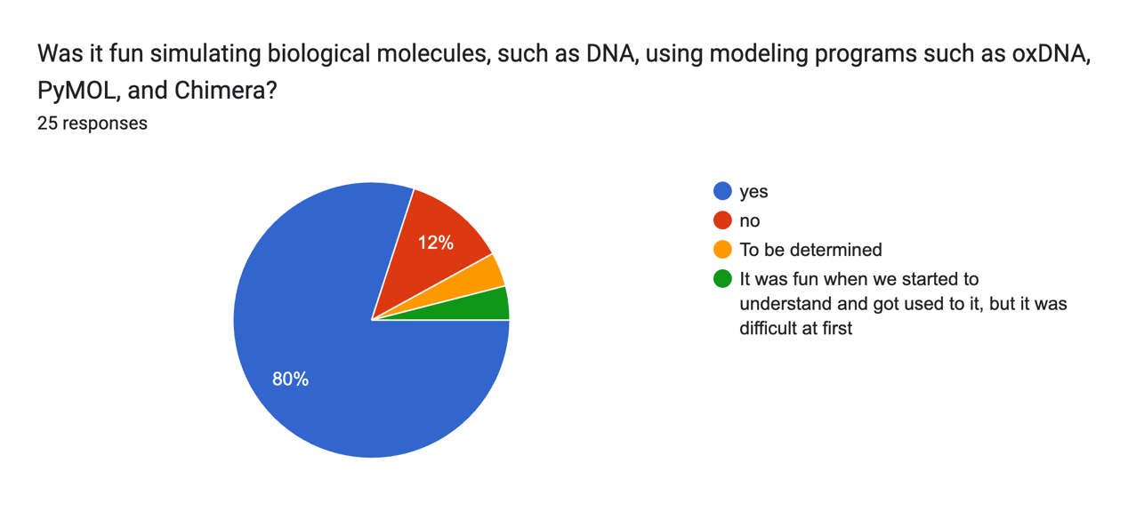
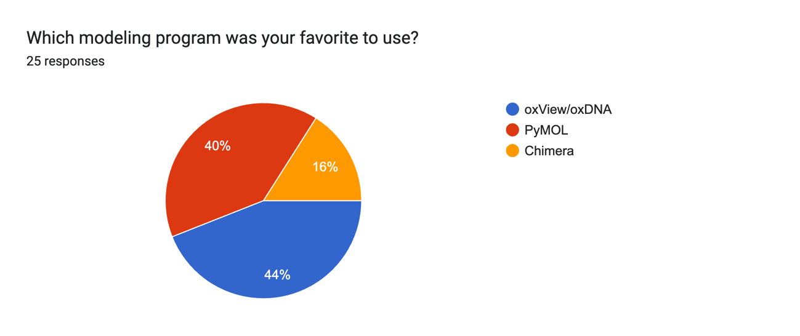
Fig. S26. Chemistry 2B students’ perceptions of modeling and simulation programs after using them as part of the synthetic biology curriculum in 2023.

PCC researchers and UCLA graduate students, serving as Learning Assistants in Chemistry 2B: quotes about DNA nanotechnology teaching experience in Chemistry 2B at PCC

-The day I went to the lab it was for the first lesson, where the class was divided in half. They would both do the hands-on lab on creating the nanostars and the modeling of said nanostars. They would do these tasks in different weeks. However, as I was helping with the teams who were pipetting and mixing their solutions, then annealing; simultaneously, there were three students who came to the lab to get help on the computer modeling. One of them voiced out their troubles with the program more than the others. She would ask me for help and as I aided her, she would quickly realize she was about to figure it out on her own. She made me realize that students, of course, have questions that need to be answered but also that Learning Assistants (LAs) can help students through other forms apart from delivering information like moral support and validation.
-During the high school outreach effort that was made during the summer, I noticed that the students were extremely interested in the research and the instruments, as was evident by their insightful questions.

-I noticed that everyone can have an appreciation for science if given the tools and trust. I learned about my own teaching style as I encouraged questions from the students. I noticed I was walking people through previous steps to get to the answers they were looking for. This in turn, made them more resourceful and receptive to the procedures because they realized every step thereafter was decided on something they were familiar with and not some random scientific interjection. I was surprised by how intuition guides us even in science. At times when I had my own shortcomings (like not operating our microscope as effectively as I'd wanted), students would just do it so naturally! I saw how everyone had their own contribution and natural curiosity. I realized also that while science was very interesting for students, many seemed to opt for careers that required science courses but mainly for income purposes which made sense in a capitalist society like the one we live in where ambition is more valued than knowledge and collective education. This made me wonder about how science and research can become more accessible and whether scientists are paid enough. In regard to teaching these lessons, I also noticed the time and work that went into preparing lessons for students. Making lessons for students who are not as familiar with the material required me to unlearn expectations and shift into using more accessible language. This has stuck with me and helped me when doing presentations about this material as well.

Student quotes about oxDNA experience in Chemistry 2B at PCC
The Chemistry 2B students were given a post-survey following the new curriculum in synthetic biology, and specific questions asked them about the modeling and simulations.

Many Chemistry 2B students found oxDNA challenging, but rewarding:
-Having to follow each step was challenging but in the end we did it.
-The programs definitely took a while for me to understand, but once I got the system down, I was able to navigate through it easier. Having pictures on the procedure helped a lot.
-It was a great experience to use a modeling program. But it was hard to follow because it was my first time using it.
-I looked over the material and it does look a little challenging, but I'm sure we will figure it out!
-It's a lot of work. I wasn't expecting it but the end results were good.
-At first it was very odd to work with because it was all new to me but after following the directions I got to understand it for a moment.
-Instructions were very clear. It was time consuming.
-Though oxView sometimes lagged a bit on my computer it was my favorite when I got it working.
-Pymol was probably my favorite because we were able to see the DNA and really view everything. My group and I did have problems in the beginning because we were all lost but eventually, we were able to do it.
-I feel like it was complicated and some parts we were unsure of, but at the same time it allowed us to understand how the DNA strands connected together and visualize DNA strands, understanding the structures of them.
-I liked it because it got me engaged and I thought of it as a video game where you can make something but still learn.
-It was definitely not easy, but it was cool seeing it through modeling programs.
-It was hard to get a good view on oxView. In the beginning, the modeling programs were frustrating to deal with because they were something that I had never worked with. After working things out it was easy to use the programs.

Some students really loved the oxDNA simulations and modeling:
-Loved it, it was intriguing!
-It was my first time working with the modeling programs, and it is very challenging, but Dr.jB provides very detailed steps that we can follow to work with the modeling programs, making it much easier.
-My favorite part of the new synthetic biology curriculum was modeling the DNAzyme using molecular visualization software. I thought it was really cool to be able to see these molecular structures up close on the computer and manipulate them. It helped reinforce my understanding of how DNA and enzymes interact at the atomic level.
-It was difficult at first, but through the help of professors and the student aids, I was able to have fun with the labs.
-It was amazing and I am glad I got to do this for the first time.
-The making of our own models putting the strands together was cool.
-It was a great experience to use a modeling program like oxDNA.
-Though there were parts where I was a little confused, I really had a great time.
-It was fun, cool, something different out of my comfort zone.
-I was very proud of creating my first nanostar on the computer. After waiting a long time for it to load, finally seeing it appear on the screen and being able to show it to my group was an amazing feeling. Even though we all worked on it together, seeing the final result made me feel really proud of what we accomplished.
-My experience is that, under the guidance of Dr. jB, I am more interested in modeling.
Some students did not like the oxDNA simulations:
-I did not enjoy it very much.
-I don’t particularly like it since it’s complicated.
-It was very unpleasant and tedious. I had no fun using these programs.
-It was challenging working with the program and modeling DNAzymes. However, the careful noted instructions and videos helped so much.

References
[1] N. Conrad, T. Kennedy, D. K. Fygenson, and O. A. Saleh, “Increasing valence pushes DNA nanostar networks to the isostatic point,” PNAS, vol. 116, no. 15, pp. 7238-7243, Mar. 2019, doi: 10.1073/pnas.1819683116.
[2] L. Rovigatti. “External forces.” oxDNA. Accessed: Nov. 1, 2024. [Online.] Available: https://lorenzo-rovigatti.github.io/oxDNA/forces.html.
[3] D. Karna et al., “Chemo-mechanical forces modulate the topology dynamics of mesoscale DNA assemblies,” Nat Commun, vol. 14, no. 6459, Oct. 2023, doi: 10.1038/s41467-023-41604-z.
[4] Created in BioRender. Blatti, J. (2025) https://BioRender.com/n36z794.
[5] Terkazaryan, E.; Safar, E.; Khosravian, C.; Mhlanga, G.; Rivera, M.; Franco, E.; Blatti, J.L. Exploring toehold-mediated strand displacement as a strategy to program DNAzyme-catalyzed peroxidation, J. Adv. Technol. Educ. 2025, in revision.
[6] R. I. Adeoye et al., “Catalytic activities of multimeric G-quadruplex DNAzymes,” Catal, vol. 9, no. 7, p. 613, Jul. 2019, doi: 10.3390/catal9070613.
[7] Paredes, Fabiana. “Simulating DNA Nanostars Using oxDNA and oxView: Tutorial.” YouTube, 15 Aug. 2024, youtu.be/_FrL3UHvhdA.
[8] P. Travascio, Y. Li, & D. Sen, “DNA-enhanced peroxidase activity of a DNA-aptamer-hemin
complex”, Chem. Biol. vol. 5, pp 505-517, 1998.
[9] Anand, T.; Salman, R.; Castaneda-Camacho, B.; Gonzalez, V.; Safar, E.; Franco, E.; Blatti, J.L. “Investigating substrates Amplifu Red and ABTS (2,2’-azino-bis(3-ethylbenzothiazoline-6-sulfonic acid) in the colorimetric detection of DNAzyme activity localized to DNA condensates,” J. Adv. Technol. Educ. Vol. 4, no. 1, 2025. DOI: 10.5281/zenodo.14933441.
[10] Terkazaryan, E; Blatti, J. “Dynamic GIF of 4 armed nanostars created on oxView and simulated using oxDNA.” YouTube, 9 June. 2025, https://youtu.be/G_R1Yf2wMC8.

